Stories from Breaking the Silence

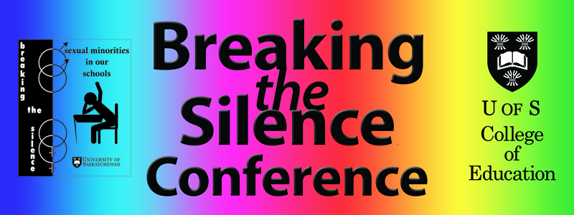

Don Cochrane
Professor Emeritus
College of Education
University of Saskatchewan

Contents
Creating a course in 1995 to explore sexual minority issues in education. 3
Seeking approval for the conference in 1997 11

Breaking the Silence Conferences (1998-2017) 13

Appendix A—Greetings from the University 84

Appendix B—Special Friday-night presenters 85

Appendix C—Conference moderators 86

Appendix D—The Peter Corren Award (2010-2017) 87

Appendix E—Posters and bookmarks 90

“Life can only be understood backwards,
but it must be lived forwards.”
Soren Kierkegaard, Journals IV A 164 (1843)

“An author should always account for the inner
prompting that leads him to his choice of subject.”
Stefan Zweig, The Story of Magellan (1938)

Creating a course in 1995 to explore sexual minority issues in education

When I reflect on my early life, I am struck by how insensitive I had been to the treatment of sexual minorities in our society. LGBT issues were never discussed in my family. Gay high-school friends (I suppose there were some) were invisible. Members of my father’s congregation were presumed to have been straight (though I learned later that there were exceptions). All I knew about “homosexuals” came from reports on bath house raids that appeared in Montreal’s tabloids such as Allo Police, Le Journal de Montreal, and Photo Police. As well, these issues were never raised in any of my university ethics classes, although they contained moral dimensions for those who had eyes to see them.

I had always been remotely aware that sexual minorities faced severe discrimination in our education system and in society generally, but I had never been moved to any concerted action to oppose it. I have often wondered why I chose (if “chose” is the right word) to take up this cause, one in which I had no first-hand and little second-hand knowledge. I certainly could have planned a smoother career path. I think the answer is simply that I saw it as a neglected human/civil-rights matter that had to be addressed. In my first fifteen years at the University of Saskatchewan, almost no one had broken the silence on LGBT issues. No undergraduate course had ever taken sexual orientation as its central focus. I knew of no precedent in other faculties of education in Canada. Without a map to guide me, I decided to create a course to explore sexual minority issues in education.
Developing the course

Creating the course was an enlightening education in itself. The purpose of my sabbatical in 1995-96 was to focus on the concept of wisdom and tease out its possible contributions to education. In April of 1996, I took a three-week holiday from that project to see if I could create a viable outline for a course on gay and lesbian issues in education.

I knew I needed to talk with some of our university LGBT students before I went any further. I felt that I needed to ask their permission to proceed. Two Canadian universities had recently experienced blow-ups when straight professors sought to explore the worlds of sexual minorities. I did not want to be accused of appropriating anyone else’s voice. Gens Hellquist made the contacts for me because I was not aware of knowing any LGBT students. Over phone calls, the three students and I decided that the subject we wanted to talk about was far too sensitive to discuss publicly in a coffee shop or a restaurant. Someone might overhear us. We met in my home where we were assured of privacy. Yes, things were just that tight in those days! I showed them my draft outline, and they offered suggestions. Most important, they gave me the green light. When I raised the issue of appropriation of voice, they responded gratefully: “You can speak where we can’t.”

Seeking course approval

One of my concerns was whether the appearance of the course on students’ transcripts might jeopardize their chances of being employed by a school board. Should we have a “cover” course with an innocuous title like “EdFdt 489.3 Education and Values” in which students could enroll but conceal the fact that they had actually taken “EdFdt 486.3 Gay and Lesbian Issues in Education”? I requested a meeting with University Registrar Ken Smith to discuss the issue. We were joined by Lea Pennock, the Assistant Registrar. For nearly an hour, we had a model academic discussion on an administrative matter. No one prejudged the question or pressed for any one answer. If only other discussions in my university career had been conducted with such objectivity, care, and respect. In the end, the three of us decided that student transcripts should reflect the actual course taken. This proved to be a wise decision—one which student accepted as a badge of honour.
Gaining approval for the course through the antiquated, laborious college committee structure was a frustrating affair at the best of times. In a period when resources were scarce and student enrolments uncertain, curriculum debates (who could teach what to whom) were often smokescreens for “turf wars”. Added to these concerns was the perceived controversial nature of the course itself.

My own Department of Educational Foundations had readily approved it in late August, 1995 and sent it to the Undergraduate Program Committee; if approved, it would go to the Faculty Executive Committee and, finally, to a general meeting of college faculty. All of this had to be completed before the proposal could be sent across campus to the Social Sciences “B” committee and then further up the university’s approval system. If you missed a rung on this ladder, your proposal would very likely be delayed a year.

It is not hard to imagine that in the mid-90s a gay and lesbian issues in education course would be seen as controversial and provoke opposition. Some colleagues might be opposed to any discussion of these issues in any of our courses, especially if the point of view adopted was to free LGBT students, teachers, and administrators from shame, guilt, and fear. My hope was that the course would have the effect of questioning the oppressive culture in our schools. I had been moved by the lines in Leonard Cohen’s “Anthem”:

There’s a crack in everything
That’s how the light gets in
I saw this initiative as a crack in the wall of silence in the college and in our schools. The course might let a little light in.
If you were opposed to the “gay agenda” (!), you could obstruct passage of the course in several ways. You could voice your disapproval of its goals openly though this response might attract too much counter-productive resistance. It might be more effective to hide antipathy behind procedural manoeuvres. You could stall, obstruct, and delay by requesting additional letters of support from far-flung agencies; claim that approval was being rushed and that more time should be given to consider the merits of the course; argue that its content was “unbalanced” (for example, it had not given any consideration to the Vatican’s position); claim that extra psychological support might be needed but had not been recognized or mandated in the outline; and so on. Some of these tactics surfaced.

I had solicited an assessment of the course outline from Gens Hellquist. To him, it appeared to be “an exciting course” that was “quite inclusive”. The only area that he thought might be missing was “the implications of not providing a supportive environment for lesbian and gay youth.” He also thought it might be valuable to provide our students “with opportunities to meet…gay and lesbian youth.”

On September 21, 1995, my head of department received a letter from the Assistant Dean, Undergraduate Program in which he reported that some members of his committee believed that “there was a strong possibility that the course would give rise to situations where counselling would be needed.” As well, he pointed out that the calendar entry “specifically mentions the dilemmas faced by school counsellors.” Thus, I would need “letters of support from the Departments of Educational Psychology and Psychology and other units as [I saw] fit before they [would] consider this course.”

As for the need for counselling, Mr. Brian Berezowski, vice-president of “Gays and Lesbians, University of Saskatchewan” (GLUS), replied rather tartly to members of the departments of psychology and educational psychology on October 3, 1995:

The Executive of Gays and Lesbians, University of Saskatchewan has met and discussed the observation [that there was a strong possibility that the course would give rise to situations where counselling would be needed.] It is not immediately clear what population the committee had in mind….Were they thinking that homophobic students might need help? We assume that gay and lesbian students (“in” or “out”) were also the subject of their concern. The course raises issues in education (not counselling or psychology), and these are ones which we have had to live with for a very long time with little or no help from anyone. Were we to sign up for the course, we do not believe that this would cause us any difficulty. On the contrary, we believe that we would experience relief for at last our issues would be out in the open.

In my letter to the heads of the two departments, I noted that “the possible need of counselling was not expressed when feminist and multi-cultural courses were introduced, yet issues of personal and societal repression [were] central to their content.” Why was a gay and lesbian issues course being singled out? Along similar lines, Jim Cheesman, head of the Department of Psychology, pointed out that “the university should not avoid offering courses on controversial topics because someone might be distressed about the topic and need counselling. This would rule out courses on suicide, race relations, women’s studies, etc.”

On the second issue, I replied to the heads of the two departments that the kinds of dilemmas referred to were ethical. Part of my qualification to handle such dilemmas could be found in my Ethics in School Counseling (1995).

To my memo of October 20, 1995, the acting head of Educational Psychology wrote, “I have spoken to several members of the Department of Educational Psychology on your course, and we do not see any problems with the offering. Personally, I think the course is an important and useful one.”

The program committee duly approved the course and sent along to the next hurdle— the Faculty Executive Committee (FEC). At its meeting on November 28, 1995, several “concerns” were raised:
- the proposal should indicate that the departments of Educational Psychology and Psychology had been consulted;
- there was a need to consult all departments in the college since they, too, were involved with gay and lesbian issues;
- students might be handicapped when seeking employment if the course were to appear on their transcript;
- the terms used in the proposal were drawn from “popular culture”—for example, “gay and lesbian” was used rather than “homosexual” and we needed to use terms that were “less loaded”;
- the course seemed to neglect the controversy around issues of homosexuality; and
- the course appeared to support “homosexual College of Education students [more] than to consider the issue of students in schools,” and that it was a course for “homosexual teachers and not about homosexual students.”

The course proposal was then returned to me. In spite of these reservations, the chair of the committee moved in a December 1, 1995 memo that the course be placed on the agenda of the full faculty meeting scheduled for December 5, 1995. But after memos to the dean of the college from two professors (December 2 and 3), the chair of the FEC withdrew his motions because he now thought that they were procedurally incorrect. I responded immediately in a memo of my own sent to all faculty in the College of Education in which I served notice that I would move the motions that the FEC had withdrawn.

As for the substance of the reservations raised by the Faculty Executive Committee, I was able to report that
- the departments of Educational Psychology and Psychology had been consulted;
- no other departments had been seriously or systematically involved with gay and lesbian issues (there had been near total silence);
- that the transcript question had been thoroughly discussed with the university registrar and his assistant;
- that the term “homosexual” with its pathological baggage was more loaded than “gay and lesbian”;
- that controversy around issues of “homosexuality” would inevitably arise; and
- that a fair reading of the course outline would reveal that the charge that the course appeared to support “homosexual College of Education students more than to consider the issue to students in schools” was patently ridiculous.

After a full debate in which several colleagues demurred, “EFDT 486.3 Gay and Lesbian Issues in Education” was approved. At the end of the meeting, supporters gathered to give one another hugs–the only time in my thirty-five-year university career that I experienced such a response following a faculty meeting. That day, we knew we had done something good.

The proposed course was not impeded by any of the higher university committees, and so, I was able to teach the course for the first time in the spring of 1997.

Teaching the course

We met on Tuesday evenings in Education 2051–a classroom so out of the way of regular night students that no one would be seen going to the “gay class.” For some, being seen might be the equivalent of being outed. Seventeen students registered in that first class. After three or four weeks, they so felt safe that they were happy to reveal their own orientation. The class was comprised of nine straight and eight LGBT students. A couple of weeks later, some of my straight students asked me whether others in the class would be prepared to divulge their coming-out-at-home stories. After consulting, they all readily agreed to share their stories. Soon, we were all in tears.

For a homework assignment one week, I asked students to find the names of at least twenty well-known out LGBT persons. At the next class, each student, in turn, had to shout out his or her 20+ names. One student had gathered over 160 names. She did a lot of shouting that night! The exercise was very liberating. It was as if we had exorcized a demon—the demon of silence.

I urged my students to focus their research papers on a topic that would illuminate our circumstances in Saskatchewan. We knew much about reports, agencies, court cases, and so on in Boston, Vancouver, and Toronto, but we were largely ignorant of what was going on in our own province. One student undertook to interview three young people. Two had switched high schools to avoid harassment, and the third had dropped out altogether. When I saw how excellent her first draft was, I exclaimed, “This is far too good to be written for an audience of one! We need to have a conference! We’ll have a conference in November!” One of my students, Brian Berezowski–a wiser and younger head than mine–tapped me on the shoulder and said, “Don, November is too soon. You will have to form an advisory board, settle on your purposes, assess community resources, find your audience, locate the sharks in the water, plan your publicity, and so on.” “Well, then,” I said, “we’ll meet in March” and for the next twenty years we met in March.

Seeking approval for the conference in 1997

The first step was to meet with Dean Ken Jacknicke. I thought this would be a formality, but he insisted that I bring a proposal to the College’s Administrative Advisory Committee (AAC). I thought that this was entirely unnecessary, but of course I complied. This is just one example of why Ken was a good dean, and why I would never have been one!

I proposed three major purposes for the conference:
- To create a forum for sharing information about gay and lesbian educational issues in Saskatchewan;
- To provide an opportunity in an academic setting for networking among those in the university and those in the wider community;
- To stimulate research into LGBT educational issues in our province.

Once AAC had approved sponsorship of the conference, we had immediate access to room space, poster publicity, security, culinary services, and so on. I was able to print on every poster and on all other publicity over the next two decades, “Sponsored by the College of Education.” As legitimacy was assured from the start, I could proceed to form an advisory board. We chose Saturday, March 21, 1998 for our first one-day conference so that it would coincide with the Doug Wilson Award that was to be celebrated that evening.
Brian had been right: we had many questions that needed to be settled before we could plan the details of our first conference. At the first meeting of our advisory board on December 12, 1997, we asked,
- Who might be additional new members for the board?
- What avenues are there for publicizing the conference?
- Do we need a conference fee?
- Do we need campus security?
- Should the media be invited and, if so, under what conditions?
- What groups might provide displays?
- What should the range be of program activities (drama, panels, art displays…)?
- What interesting research is being done and where?
- Is there a need for a policy workshop?
- Should we schedule a special session for target groups (for example, school counsellors)?
- Should we undertake a review of court cases?
- Should we issue a call for papers or develop our program by invitation?

In its twenty years, Breaking the Silence was buoyed by the active involvement of many very extraordinary people: three Members of Parliament (1999, 2010, and 2017), two Ministers of Education (1998, 2005, and 2007), a college president (2003), two provincial MLAs (2010 and 2014), a gold medal Olympian (2000), a president of the Saskatchewan Federation of Labour (2000), a Lieutenant Governor of Saskatchewan (2006), a Deputy Minister of Education (2008), a prominent American Episcopal bishop (2003), a constitutional lawyer who has won several cases in the Supreme Court of Canada (2002), a Canadian athlete of the year (2013), two famous entertainers (2009 and 2014), a recognized authority on homophobia in university sports (2001), three Chief Commissioners from the Saskatchewan Human Rights Commission (2002, 2008, and 2013), and a superintendent from British Columbia’s Burnaby School District (2004). As well, at every conference, a senior university official welcomed participants to campus.

First conference, March 21, 1998

Greetings from the University:

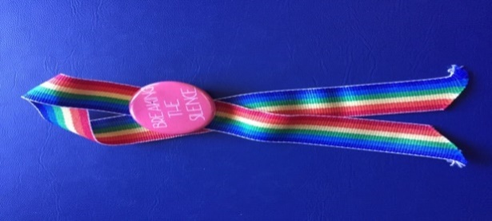
Vice-President (Academic) Michael Atkinson

Introduction: Scott Blythe

Special guest: Delvin Vriend, “The importance of inclusive human rights legislation for teachers”

Panel: “Bringing the issue to home and school”

Chair: Rev. Colin Clay, University of Saskatchewan Chaplain

Saturday morning program
Our program started on a high note! Delwin Vriend made a cameo appearance at 9am to discuss his Supreme Court case. Vriend was at the center of a landmark provincial and federal legal case [Vriend v. Alberta] concerning the inclusion of sexual orientation as a protected human right in Canada. The Supreme Court rendered its decision on April 2, 1998 less than two weeks after our conference.

This presentation was followed by a panel (“Bringing the issue to the home and school”) and featured two gay high school students, a gay parent, a member of PFLAG, and a gay teacher. On the Thursday before the conference, the teacher decided that he could not go through with it because he feared losing his job. His presentation was recorded by John Lyons (a College of Education faculty member) and broadcast over Quance Lecture Theatre’s sound system. The teacher’s chair was left empty on stage. He listened in the audience to his contribution read by someone else.

Over the noon hour, artists Bev McNaughton (“Sutures”) and Duncan Campbell (“Assume your position”) exhibited and discussed their works.

Saturday afternoon program
In the afternoon, Murray Scharf (SELU) and Don Cochrane led a workshop (“Improving human rights policy and procedures in school districts”) in which they reported on their research on the extent to which school policy had been brought in line with the 1993 amended provincial human rights legislation. A second workshop led by Gens Hellquist, Diane Kendall, and Sharon Fyke (“Building safety for students”) focussed on helping schools become safer and more inclusive for all students and teachers regardless of sexual orientation.

Two films: “It’s Elementary” (introduced by a Saskatoon elementary school teacher) and “Out for a Change: Addressing homophobia in women’s sports” (introduced by Kim Grant, a member of the UofS Huskies women’s basketball team).

Closing
The highlight of the conference was the address by The Honourable Pat Atkinson, Saskatchewan’s Minister of Education. She had made a commitment to be present at a function in Prince Albert that Saturday morning, but assured us that she would return to Saskatoon in time to close the conference. Pat was introduced by Dean Ken Jacknicke of the College of Education. As far as we could make out, this was the first time in Canada that a provincial education minister had spoken about how important it is for public schools to be safe places for GLBT youth.

Notes
From the very first year, the university administration supported the conference and provided it with legitimacy. As President George Ivany was out of the country on the day of our first conference, Vice-President (Academic) Michael Atkinson graciously welcomed participants to the university.

Attendance was modest–about 80 people in all (of which 15 or so were members of our advisory board!), but we rejoiced for it was a start. There were only about four young people all of whom were supported by one or two of their parents. Contrast this with attendance over the last four or five conferences where on average fifty teens attended without needing to be accompanied by parents. The scene certainly had changed over the life of the conference! Our first program was not elaborate. There were few local academics, activists, students, or support group resources for us to draw on. In any case, we were not expecting a large number of participants.

The Prairie Messenger reported on the conference an article by “Phyllis” and in a College of Education news release by Lawrie McMahon (March 24, 1998).

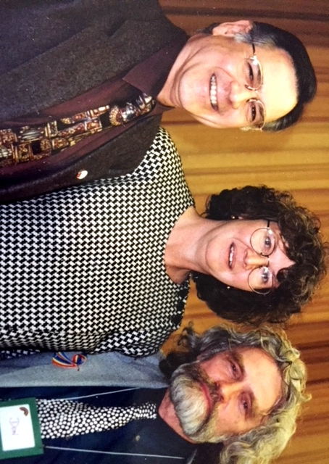

Dean Ken Jacknicke, The Honourable Pat Atkinson,

and Professor Don Cochrane, conference organizer.

Among our conference participants were Cecilia Forsyth, communications director of REAL Women of Saskatchewan, Maurice Vellacott, M.P. for Saskatoon-Wanuskewin, and three members of the Lloydminster branch of the Promise Keepers. All participated fully in the conference. They did not, however, return for future conferences. Not everyone was happy with the founding of Breaking the Silence.

Second conference, March 12 and13, 1999

Having run a modestly successful one-day conference in 1998, we were emboldened to add a “Friday-night special.” Alas, most of us had few or no contacts with anyone who could make a presentation and who could also draw a crowd. Fortunately, Gens Hellquist, one of our advisory board members, had worked several times with Svend Robinson and offered to invite him on our behalf. Much to our surprise and delight, Svend accepted. His commitments on the Friday and Saturday of our conference were many. He had committee meetings in Ottawa on the Friday morning, caught a 1:30pm flight to Saskatoon, arrived at 5:30pm, had a light meal with Gens, spoke most eloquently beginning at 7:30pm, left for a 9:30pm flight to Winnipeg so that he could attend a breakfast meeting in that city early the next morning! We always have remained deeply indebted to Svend for shoe-

horning us into his tight schedule. He provided us with the lift-off we

needed and sent the conference into orbit.

Greetings from the University of Saskatchewan

Acting Dean Tom Wishart, Arts and Science

Friday night special presentation:

“Reflections on Breaking the Silence,” Svend Robinson, former MP for Vancouver-Kingsway who was introduced by Gens Hellquist, Director, GLHS

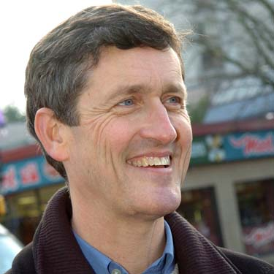

Saturday morning program

Opening address: Murray Warren, teacher and petitioner in the Surrey Book Banning Case, “What we learned through our struggle in British Columbia.”
9:30-10:30—Panel with students, parents, and teachers: “What would have made a difference in our school?” Chaired by Jason Aebig, USSU President
Panic! In a phone call from Regina, Guy Michaud told me on February 25 that because of a labour dispute at the CBC where he was a producer, The Oscar Wilde Theatre Troupe would be unable to perform on Saturday morning. Ian Nelson came to our rescue. He and I put together a script from several plays and had members of our committee perform in Quance (seated around the hall and popping up when one of “our” characters had a part). It worked out very well.
Saturday morning and afternoon sessions
- Murray Warren, “Recent developments in educational issues in BC”
- Jan Padgett, “Producing a video on G&L adolescents”: An insider’s saga and “rough cuts of her new video”
- Sharon Fyke and Gens Hellquist, “For educators – Making a difference in schools”
- Val Korinek and Don Cochrane, “Silences in the university curriculum”
- The film “It’s Elementary”
- Noelle Lucas (one of Val Korinek’s graduate students) made a presentation based on her research on grassroots lesbians and lesbian-feminists during the 1970s to 1990s
- Jeffrey Keller, “Sex education as a public health issue”
- Ailsa Watkinson and John Foster, Ariel F. Sallows Professor of Human Rights in the College of Law conducted a workshop on “Understanding the Saskatchewan Human Rights Code”

Closing: “A Gay realities: Voices from amongst us” by the Jane Rule Players”

Saturday evening, March 13 – Doug Wilson Award

Third conference, March 17 and 18, 2000

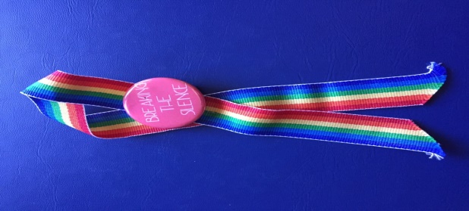
Conference Theme: “skweeze LIFE, BE REAL”

Greetings from the University of Saskatchewan:

President Peter MacKinnon

Special Friday-Night Presentation:

Mark Tewksbury, Canada’s swimming gold medalist,

Barcelona Olympic Games (1992)

Until Penny Oleksiak’s heroics at the Rio Olympic Games in 2016, Mark Tewksbury’s gold medal in the 100-metre backstroke in the 1992 Barcelona Olympics had been the last gold medal won by a Canadian in Olympic swimming competition. Following the Games, Mark became a much sought after motivational speaker. On December 15, 1998, Tewksbury came out publically as gay. Given that we had a very short “track record,” we thought we had little chance of attracting him to our fledgling conference. There was another issue: fees. Mark was drawing four-digit sums for a single appearance. In our letter of invitation, I explained to him that we had no major sponsor and that to protect our autonomy we would not seek one. We lived off our modest registration fees and did not want enter into detailed arrangements with him before we confronted the issue of fees. Mark’s response? “I know what you are trying to do. Pay my airfare, my hotel accommodations, and my meals. I am coming.” Extraordinary! Like Svend, Mark, too, remained a “friend of the conference”.

Scott Blythe, USSU VP Student Affairs, welcomed Mark by showing the Olympic the 1992 100-metre backstroke final: “Even though all present knew who would win, the theatre was silent….A resounding cheer arose when we saw the then 24-year-old Calgarian jump up and down in the water when he recognized his Olympic victory.”

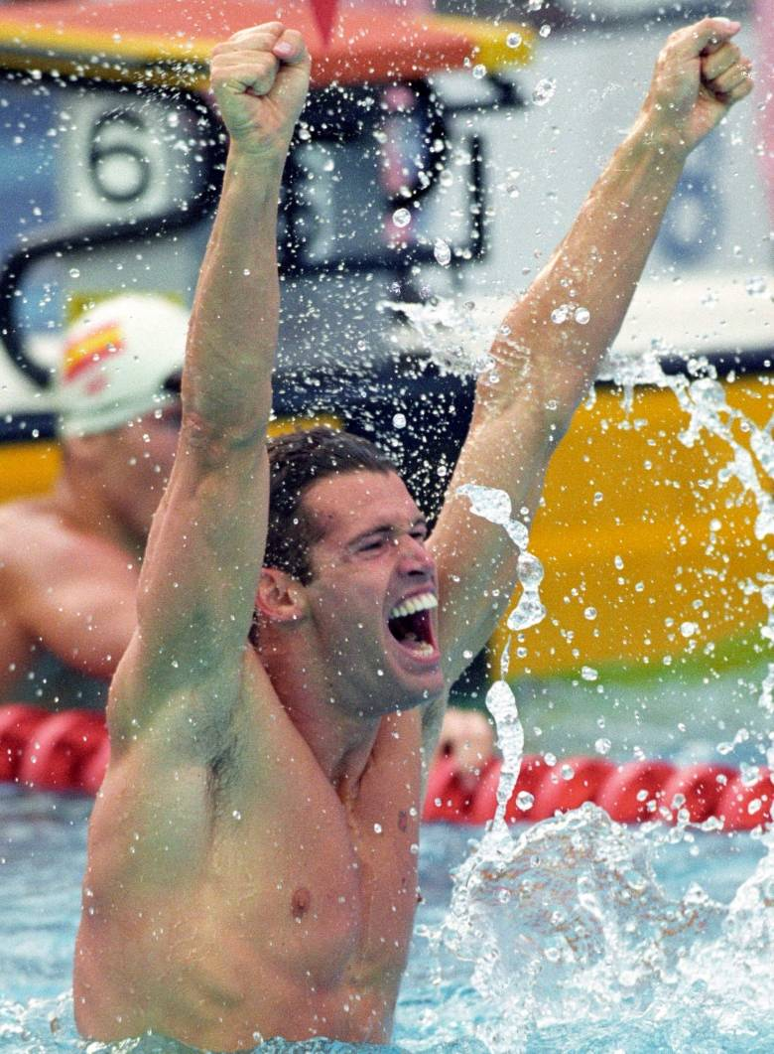

Although the moment occurred almost eight years ago, it was a charged beginning to the evening. Nathalie Andrade, writing for The Sheaf, reported that it was “an unforgettable evening with an inspiring message that transcended sexual orientation, race, culture, gender, ability, and age.” From the first moments, he had his audience in the palm of his hand. But through all the laughter he generated (often at his own expense!), Mark delivered his life philosophy which squeezed meaning out of odd title of his presentation: “skweeze LIFE, BE REAL!” Life, he told us is “all about attitude” (it is the choices we make that colour how we see life); “life is living in the moment” (because that it where life is lived); and always be your best (which results in our unwittingly being an inspiration to others).

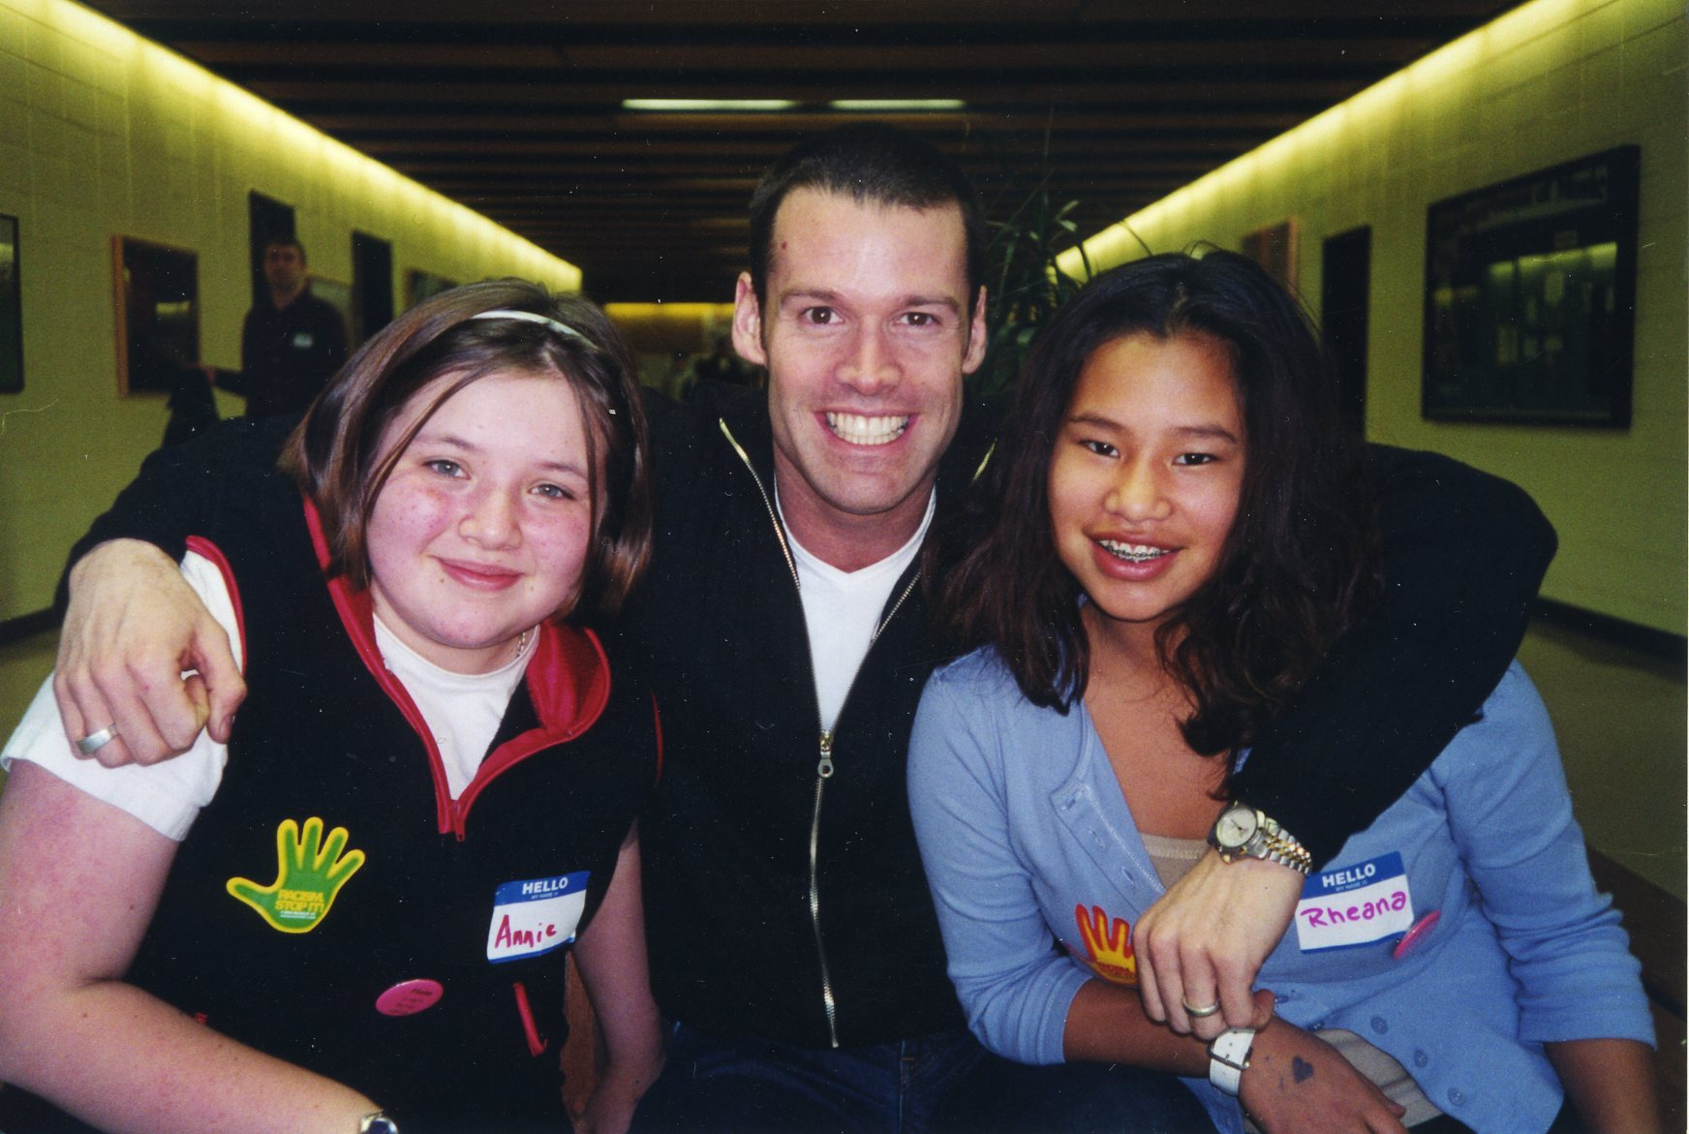

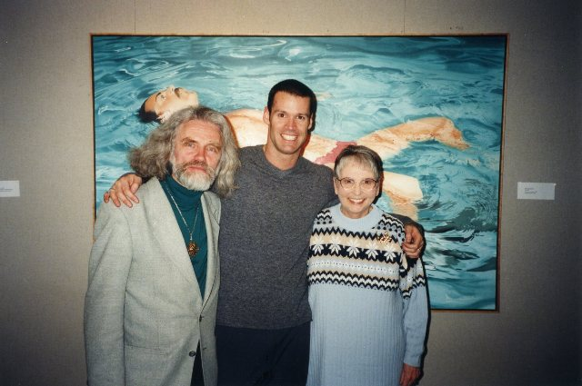

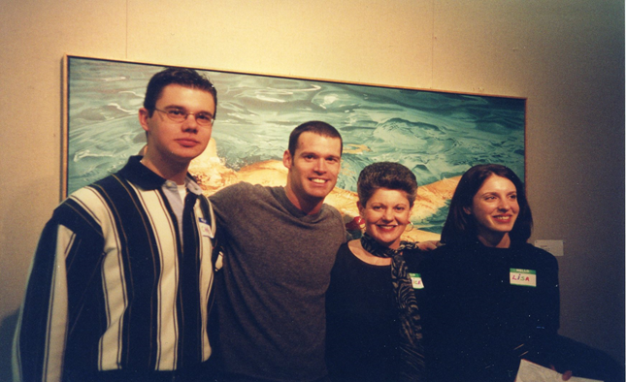

Saturday morning program
Barb Byers, a former president of the Saskatchewan Federation of Labour and the first female president of the Saskatchewan Government Employees' Union, opened the Saturday program with a barn-burner address in which she decried the discrimination against LGBTers in all workplaces.

During the 1999-2000 planning cycle, the advisory committee had debated whether we should give representatives of the STF, SSTA, LEADS, and the Department of Education a prominent plenary session on the Saturday morning. The question to be posed to the four provincial “stakeholders”—as they grandly called themselves—was ‘what is your organization doing to improve the lives of LGBT students and teachers in Saskatchewan schools?’ Those who opposed issuing the invitation argued that these people always control the megaphones and, because they have been doing next to nothing on this issue, they should not be given pride of place. Instead we should turn to activists. The other side agreed that our provincial leaders were doing next to nothing but, if we were to give each of these outfits just ten minutes, they would be exposed. Fortunately, the latter position prevailed.

Panel participants:

Jim Hopson, President, LEADS

Gillian McCreary, SaskEd

Doug Willard, President, STF

Barry Bashinski, SSTA

Donna Scott, Saskatchewan Human Rights Commission

Moderator: Associate Dean Vivian Hajnal, College of Education

What resulted was one of the most dramatic moments in the history of the conference. In 2000, Jim Hopson was the president of the (LEADS). On the Friday evening, Mark Tewksbury had moved everyone—Jim included—with his extraordinary presentation. Jim began his Saturday morning panel remarks with these words:

“I have been a football player and have coached boys’ hockey and football for many years. I saw myself as making men out of boys. I thought I was part of the solution; last night, I realized that I was part of the problem…. I prided myself on being an advocate for special-needs kids, women, and minorities but until now not for gays and lesbians. I’ve been one of those people who had difficulty even talking about the issue because of the background and experience I’ve had.”

Hopson said that he had seen a lot of homophobia and gay and lesbian bashing in the sports world. “I participated and I stood silent and I am not proud of that…That’s why I thought it very important for me to step forward at this conference and voice my opinion and be an advocate for all people and show respect for all human beings whoever they are.”

The audience gasped! Had we just heard what we thought we had heard? We had. For Jim, it was a “Saul on the road to Damascus” moment. He immediately became an outspoken champion for LGBT rights in his Prairie Valley School Division and he remained a staunch supporter of the conference (see the entry for 2013).

Thank you, Mark, for making this kind of transformation possible.

Saturday afternoon program

Paul Clarke, “Protecting the human and constitutional rights of gay and lesbian educators”

Don Cochrane and Val Korinick, “LGB studies at the University of Saskatchewan?”

Beverley Dent and Irving and Joyce Hastings, “Violence in school—Support at home”

Gens Hellquist, “Making your classroom safe for gays and lesbians”

Kristine Barr (Member, Winnipeg public school board), “Cross-currents in G&L education politics”

Resource Room, “Classroom resources and more”

Plenary session: Warren Linds, “Animated drama”

Closing remarks: Gillian McCreary, Executive Director, Planning, Evaluation and Children’s Services, SaskEd representing the Honourable Jim Melenchuk, Minister of Education

Participants: 150

Fourth conference, March 16 and 17, 2001

Conference Theme: “Changing the Game: Making Sports

Safe for LGBT Athletes and Coaches”

Greetings from the University of Saskatchewan:

Dean Robert Faulkner, College of Kinesiology

Special Friday-Night Presentation:

Pat Griffin, University of Massachusetts—Amherst, a leading researcher on homophobia in school and university sports and author of Strong Women, Deep Closets (1998).

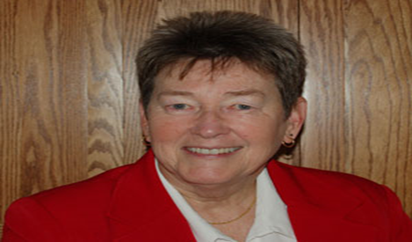

Introduced by Tara Bilash and responded to by Dr. Louise Humbert, College of Kinesiology.

In her keynote address, Pat “did not pull any punches: Silence kills as surely as violence does. Inaction on the part of adults and coaches is every bit as dangerous as violence…. [M]aking schools and universities a safe place for gay and lesbian athletes amounts to nothing short of saving lives. It’s a serious opportunity and, at the same time, a responsibility…. It’s about making our schools safe and making these young people feel good about who they are and realizing that you’re just fine the way you are.”

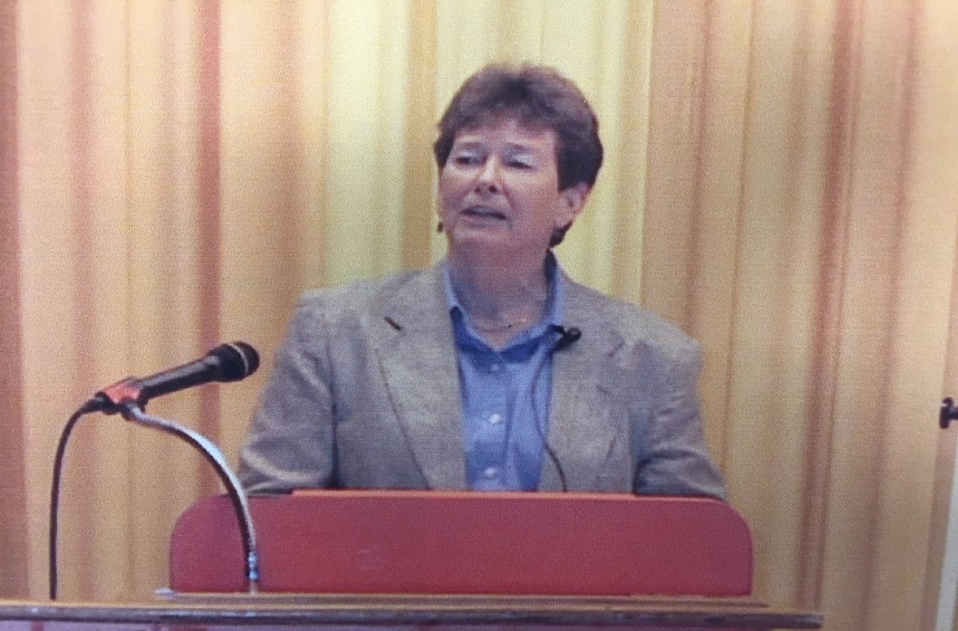

Notes: We had heard the Bill Whatcott and a band of his supporters were planning to picket our conference. A few days before the conference, I phoned University Security to discuss what precautions we should take and what support the security division might offer. Without hesitation, the chief of security, Bob Ferguson, offered us two of his officers. He had only one question: “Do you want us in plain clothes or in uniform”? I opted for the uniformed variety! They were there that Friday night and Saturday morning and stayed until I judged the situation safe.

That arrangement went on for the next three years (Whatcott and company did return in 2002). Thereafter, I would phone Security a few days before the conference and each year the chief officer assured me that his people would be briefed and on call should they ever be needed. This is just another instance of the quite extraordinary support the university gave us for twenty years.

I learned so much from Pat. I didn’t know how to handle/engage protesters. Pat did. Just before she was scheduled to speak, she went down the ramp of the Education Building to meet the placard-carrying crew. When she returned, I asked how it had gone. She told me she had offered them two minutes in which she would listen, and then they would have to give her two minutes to hear her. “Of course,” she said, “they could never shut up, and so I had to keep reprimanding them and pointing out that they had broken our agreement. They are always like that!”

The next year, Whatcott and group were back and, having learned from Pat, I went out to meet him. We had a very civil conversation and agreed to meet Bill Whatcott for coffee sometime in the future. Thanks, Pat!

Saturday afternoon program:
- Interactive Theatre led by Warren Linds: “Life in the locker room, reality on the playing field - Act 1”
- Bob Green, “League of peaceful schools: Respecting diversity and promoting inclusion in caring schools”
- Don Cochrane, “Conducting an inventory of our own attitudes towards gay and lesbian teachers and students and measuring the climate in our own schools”
- Legal update: Dr. Paul Clarke, University of Regina: “A review of current cases”
- Panel: “Athletes and coaches discuss homophobia in high school and university sports”
- James McNinch, U of R, “FAGS in the locker-room and a DYKE in the lab: Preventing homophobic comments and name-calling (three activities for teachers)”
- Don Zeman, U of S, “The challenge of being a competitive athlete and being gay”
- Andre Grace, Fiona Cavanagh, Candace Ennis-Williams, Robert Mizzi Michelle Tsutsumi, and Kris Wells, “Queer initiatives in the Faculty of Education, UofA”
- Doug Jaques, “The Doug Wilson Affair: A preliminary study”
- Video: “Out for a change: Addressing homophobia in women's sports”
- Video: “It's Elementary”

Doug Wilson Awards, College of Education, 7:30pm

Fifth conference, March 15 and 16, 2002

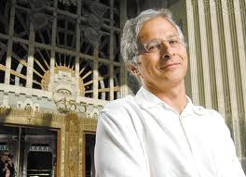

Conference Theme: “Banned in BC: Three Little Books”

Greetings from the University of Saskatchewan:

Associate Dean Vivian Hajnal, College of Education

Special Friday-Night Presentation: Joe Arvay, Q.C. who took the “Surrey Book Banning Case” to the Supreme Court of Canada

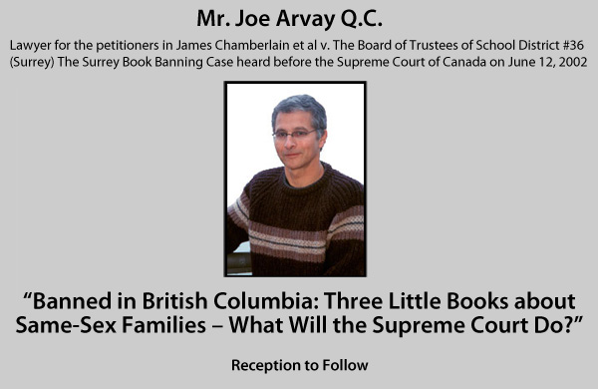

Introduced by Kim Tadei and thanked by Paul Clarke.

Friday night program

We observed a moment of silence to remember Peter Millard, an outspoken advocate and supporter for years at the UofS on LGBT issues on campus and in the community at large.

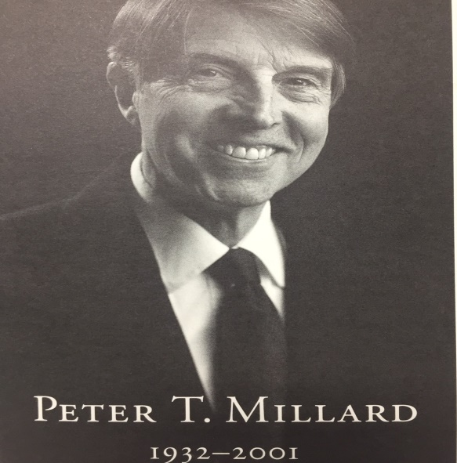

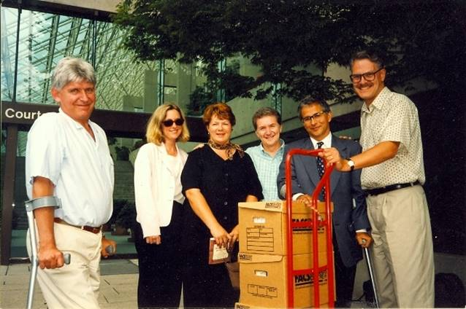

The “Arvay team” at the end of the appeal to the BC Supreme Court

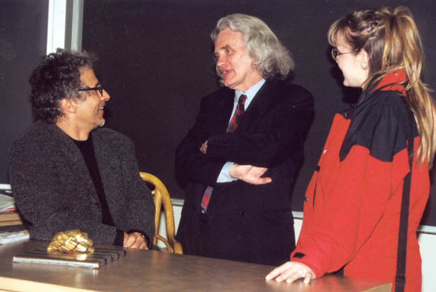

Joe Arvay, Don Cochrane, and Brandi Panasiuk converse after Joe’s presentation.

Greetings from the President conveyed by Dean Ken Jacknicke

Saturday morning program

Film: The Saskatchewan premiere of the NFB’s new video Sticks and Stones introduced by the director, Jan Padgett. Jan related some of her many difficulties in producing these videos.

A panel: In April, 1999, Saskatoon Dr. Ivan Yackel, Director of Education for the Saskatoon Public School Division, created an ad hoc committee to investigate LGBT issues in the school system and to make recommendations for improvements. The committee submitted its report in June, 2000 recommending mandatory training on LGBT issues for all division staff, enhanced curriculum, and increased information in school resource centres.

Donna Scott, Chief Commissioner of the Saskatchewan Human Rights Commission, chaired a panel consisting of Dave Glaze (teacher from Hugh Cairns V.C. School) and Paul Jacobi (teacher from Nutana Collegiate), Sigrid Hansen (Chairperson, Division Services, Saskatoon, Public Board of Education and Ad Hoc Committee Chair), and Gordon Wyant (Chair, Saskatoon School Board).

Note: Mr. Wyant had agreed to participate, but his administrative assistant phoned on the Thursday before the conference to say that he would not be able to attend because “he had to be out of town.” His office did not offer a substitute from the elected board. We left his chair on stage empty. CTV News included a shot of the empty chair and commented on it. We heard later that Wyant had been miffed by this coverage. We were miffed, too, by his sudden withdrawal.

In a letter dated March 12, 2002, Mr. Wyant offered a more formal explanation for his absence: as the “Board has received the report for information only, it would not, in [his] view be appropriate for our School Division to participate in a panel discussion on a report which has not been endorsed by our Board.”

Saturday afternoon program

Cheryl Erlandson unveiled two new STF documents—“Breaking the silence on sexual differences” and “Uncovering stones: Addressing issues of equity in the staffroom.”

Jan Padgett introduced a rough cut of the film “Tell me why”

Kim Tadei, “Are you brave enough to put this book in your school library?”

James McNinch, “It’s a drag doing drag in teacher education”

Closing: Interactive theatre led by Warren Lind – Act Two

Sixth conference, March 28 and 29, 2003

A University of Saskatchewan Public Lecture

Knox United Church, 838 Spadina Crescent East, Saskatoon

Greetings from the University of Saskatchewan:

Dr. Ken Coates, Acting Provost and Academic Vice-President

Bridge City Chorus – “Homophobia” and “Our song will live on”

Welcome to Bishop Spong from Mr. Joe Arvay, Q.C.

Introduction of Bishop Spong

Dr. John Thompson, St. Thomas More College

“The Christ Who Breaks the Boundaries of Prejudice”

Bishop John Shelby Spong

Thank you

Ellen Quigley

St. Peter the Apostle Choir and the Bridge City Chorus – “Spirit Blowing through Creation” and a “Sending Forth” – Organist: Ms. Pat Diebert

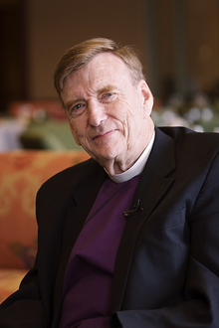

For many years, Bishop Spong wrote a bi-weekly electronic newsletter. This is an extract from the one he wrote after spending the weekend with us:

Recently, it has become apparent to me that the words “silence” and “silent” are being used in a unique way in the public arena. These words seem to carry with them a conspiratorial connotation, especially when they are related to issue of human sexuality. The cover up of the molesting of children by priests in the Roman Catholic Church has been referred to as a “conspiracy of silence.” The number of women who appear to have been abused by male relatives in the childhoods has been called the “silent shame”…. In early spring, I gave a keynote address to the 6th annual “Breaking the Silence” conference in Saskatoon. This regional conference sponsored by the University of Saskatchewan was begun to help those who are the professional teachers of our children to understand homosexuality. In each of these instances, the words “silence” and “silent” referred to a sexual scandal with the implication that silence was being used to suppress a sexual reality.

The Canadian conference illustrated this principle well. The silence being discussed here was the inability of people in public education to deal with the issues of sexual identity in adolescents….

Even educators seem reluctant to deal with these issues. If those responsible for the public education of our teenagers would have heard these personal stories that I heard at the conference, they, too, would “break the silence” and begin the unenviable but inevitable task of educating the public out of their fears and prejudices….

The forward-looking pioneering educators in Saskatchewan, Canada, took on this ignorance directly. They intend to break this silence, to replace fears with facts, to replace ignorance with knowledge. Their agenda was to fight prejudice by inviting people into reality…. The people in Saskatchewan have shown us a pathway into the future. Now all that needs to be done is for this format to be borrowed from the prairies of Canada and installed in school systems across both Canada, the United States, and ultimately throughout the world. It is of life and death importance. The people of Saskatchewan have acted in such a way as to hurl back ignorance and prejudice. They have said that silence can no longer be a code word for the repression of sexual knowledge. I salute them.

Saturday morning program

Welcome to the University: Dean Ken Jacknicke, College of Education

Interactive drama, Warren Linds
- Michael Hamann, “ ‘This little light of mine’ Growing up gay in the Lutheran Church”
- Paul Clark, “The Surrey Book Banning Case: The Supreme Court Judgment”

Panel: “Problematic experiences with religions” led by Gwen Dueck

Saturday afternoon program
- Gwen Dueck, STF, “Seeing the rainbow: Teachers talk about BLGT/TS realities”
- Andre P. Grace, Kristopher Wells, and Mark Holcroft, “Queer and allied educators as cultural workers: Working for social change, building inclusive communities”
- Martin Cannon, “Reflections on the regulation of First Nations sexuality”
- Brent Hocking and Kevin Kirkland, “Troubling topics for inclusive education: Becoming spiritual warriors/worriers”
- Liz Mooney and Carla Lorer, “When will it be safe? The need to go beyond lesson plans”
- Noreen O'Haire, “Seeing the rainbow: Teachers talk about BLST/TS realities”
- Karen LaPointe and Margi Corbett, “Developing policy for safe schools”

Closing: Inactive theatre, “The school scene finale”

Seventh conference, March 17, 18, 19, 20, & 21, 2004

Conference Theme: “Safe Schools for Gays and Lesbians”

The Laramie Project
STM Auditorium

March 17-21, 2004

Special presentation:

Five performances of Moisés Kaufman’s play about the 1998 murder of Matthew Shepard

Director: Karmen McNamara

Stage sets: Doug Jaques

Co-ordinator for the conference: Nicholas Fraser, LGBTA Centre Director

Among the actors: Nickolas Koupantsis and Stace Synkiw

“The LGBTA Centre’s major project of the year was producing The Laramie Project in conjunction with the Breaking the Silence Conference. This play, which ran from March 17 to 21, is one of the world’s most recognized works because it deals with the true story of a community dealing with homophobia, anti-gay violence, and hate crimes. In its four-day run about 700 people attended and over $4000 was raised for the centre’s initiatives such as updating the resource library which ha[d] grown to over 150 books this year.”

Kar

Saturday morning program

Greetings from the Government of Saskatchewan

Honourable Andrew Thomson, Minister of Learning

Greetings from the University of Saskatchewan:

Dean Cecilia Reynolds, College of Education

Special greetings from Bishop John Shelby Spong (audiotape)
- Forming and maintaining GSAs:
  - In the university–Carole Pond, Co-ordinator, Discrimination and Harassment Prevention Service, University of Saskatchewan
  - In the STF–Kit Loewen, Administrative Staff, STF
  - In schools–Patti Rowley, Teacher, Mount Royal Collegiate (who initiated the first GSA in a Saskatchewan school).

A discussion with Nickolas Koupantsis and Stace Synkiw, two members of the Laramie Project cast.

Bridge City Chorus – “Some of my best friends are straight” and “Sikuyo” (“We are walking”)

University of Alberta Agape Group

An overview the status of GSAs in Canada;
- “Lesbian, gay, bisexual, transgender, and queer visual narratives: Education, community, and culture. A multi-media presentation,” Kris Wells, University of Alberta;
- Two short skits–a meeting to set up a GSA and a GSA visualized a few months later in which students and a teacher moderator work to keep the GSA active and purposeful in their school.

“On the formation of the first high-school GSA and the education of an administrator”

John Simpson, a former principal from Coquitlam and by 2004 a super-intendent in the Burnaby School District, was scheduled to speak at 1pm that afternoon on the formation of the first GSA in British Columbia and his education on LGBT issues as a school principal. (The student who sparked this initiative was Brent Power who later would become the adopted son of Peter and Murray Corren.) Margi Corbett was to meet his plane at the airport; he didn’t show up! Alas, he had booked a flight to Regina, not Saskatoon! He phoned us in a frenzy, rented a car, and broke every speed limit en route to Saskatoon! We changed the order of our program so that he would appear late in the afternoon. He made it! His presentation would never be too late!

Saturday afternoon program:

Wes Pearce, “Edward II vs. Romeo and Juliet: The need for pro-gay choices in theatre departments”

Warren Linds, Two-hour workshop on how to develop/use interactive theatre, plus a “production” to be performed in the final session

Melanie Morrison– “Homonegativity: Early research findings”

Jay Kennard, “An STF Initiative: Safe schools and uncovering the stones”

Interactive theatre and wrap-up

Eighth conference, March 18 and 19, 2005

Conference Theme: “Helping Schools Become Positive Spaces”

Greetings from the University of Saskatchewan:

Dean Cecilia Reynolds, College of Education

University of Saskatchewan

Greetings from the Government of Saskatchewan

Honourable Andrew Thomson, Minister of Learning

Special Friday-Night Presentation:

Respect for Sexual Diversity Troupe (Saskatoon)

Greetings from the Minister of Learning, The Honourable Andrew Thomson
Introduction by Dean Cecilia Reynolds, College of Education, University of Saskatchewan
Response by Kelly Capelette, Student, Evan Hardy Collegiate
The “Respect for Sexual Diversity Youth Troupe”: a play and a workshop
Facilitator: Kit Loewen, Saskatchewan Teachers Federation

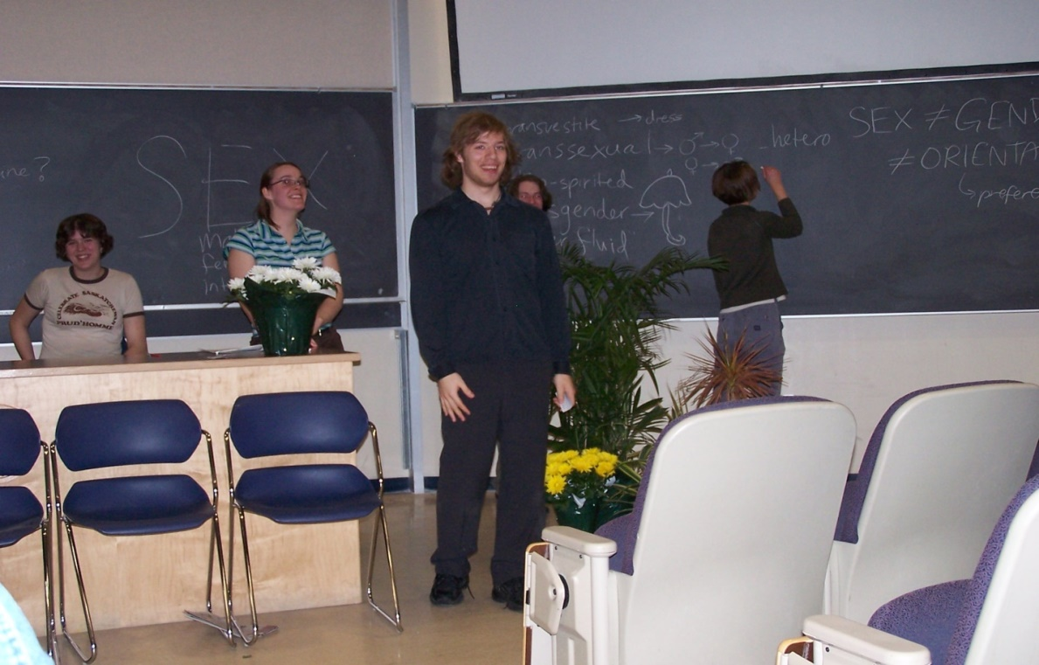
Commentators:
- Sam Tait, student, Aden Bowman Collegiate
- Margi Corbett, high school English teacher, Hague
- Dr. Jim Jutras, Director, Saskatoon Public Schools
Saturday morning program
Greetings from President Peter MacKinnon
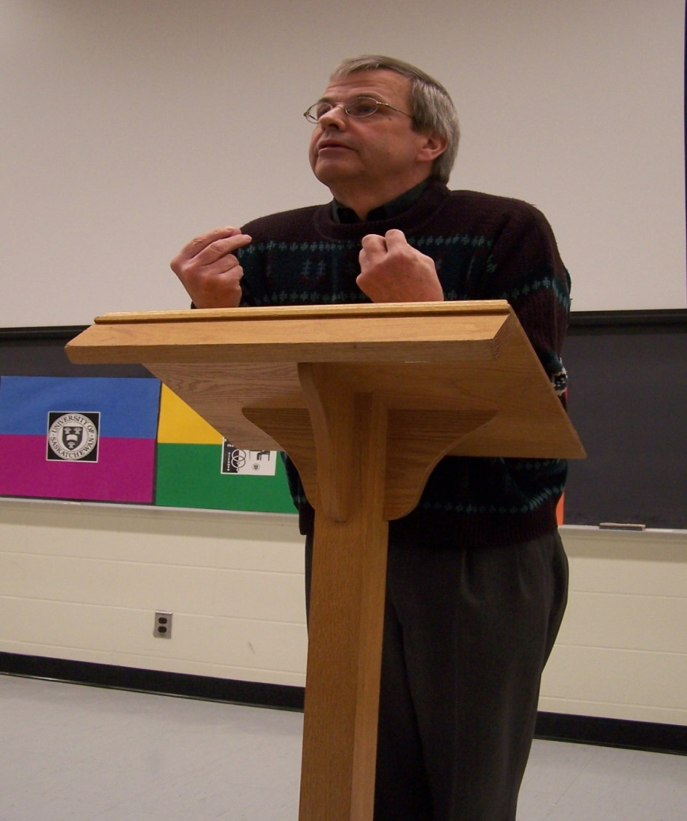
Greetings from Nickolas Koupantis and Stace Synkiw, actors in the 2004 production of The Laramie Project and introduced by Nich Fraser, the play’s director
“Fighting for equality and justice: An overview of gay and lesbian activism in the Province of Saskatchewan, 1970 to the present,” Val Korinek, University of Saskatchewan; introduced by Neil Richards
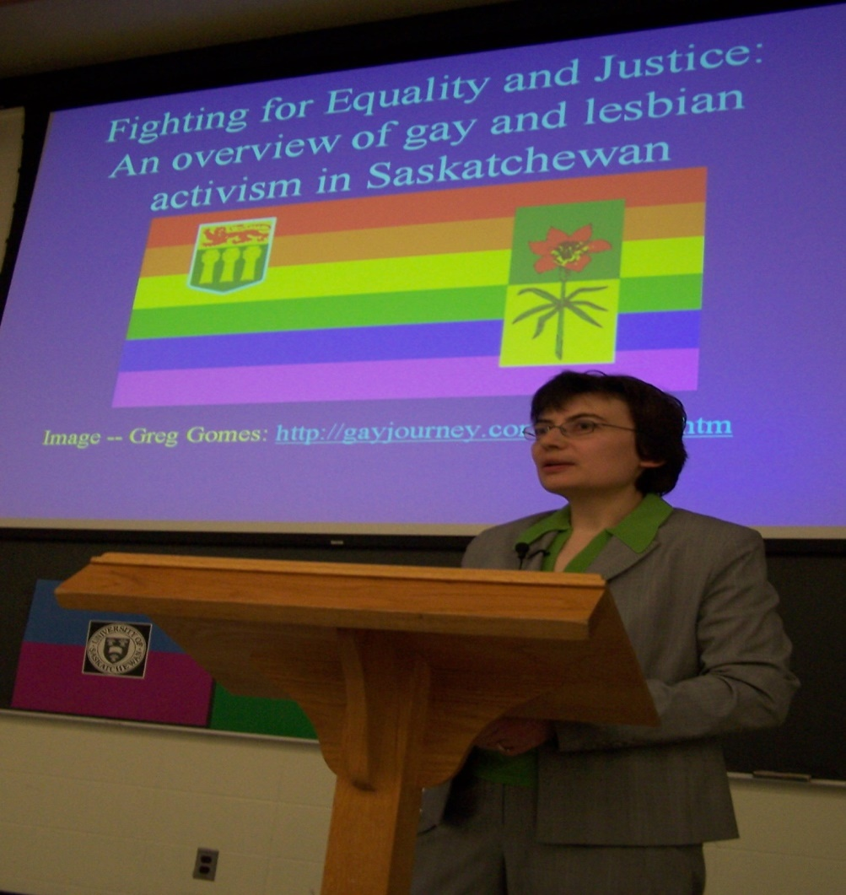
- “Starting and sustaining GSAs,” Kristy Harcourt (Program Coordinator) and Lynn Sutankayo (Education Coordinator), and four students from the “Out Is In Project,” Edmonton; introduced by Kris Wells and Andre Grace, University of Alberta
- “Catching up on the Kempling case,” Paul Clarke, University of Regina
- “Preliminary report on current research: Teacher observations of behaviour
affecting GLBT students and staff in Saskatchewan secondary schools,’ Melanie Morrison, University of Saskatchewan
- Several authors from I Could Not Speak My Heart (Regina: Canadian Plains Research Center/University of Regina, 2004)
- Grand student conclave! A GSA coming together—Visioning the ideal school. Facilitators: Jay Kennard and Brandi Panasiuk
Afternoon program
- How to respond to hallway taunts – Youth Launch
- Brainstorming to transform a school into a positive space – Youth Launch
- Publicizing inclusive activities: Posters, buttons, and ribbon making – Candace Loshack (Aden Bowman), Travis Myrol (Mt. Royal Collegiate), and Brandi Panasiuk (Delisle Composite School)
- Hearing and discussing coming-out-stories to friends and parents (university and high school students only) – Youth Launch (counselor in attendance)
- What are the best Internet resource sites? – Don Cochrane
- Out is in and youth initiatives to create safe spaces: Alberta Youth Speak OUT
- Breaking another silence: Telling our transgender stories.
Closing: Eight years of breaking the silence (and we didn’t know that we had just begun!)
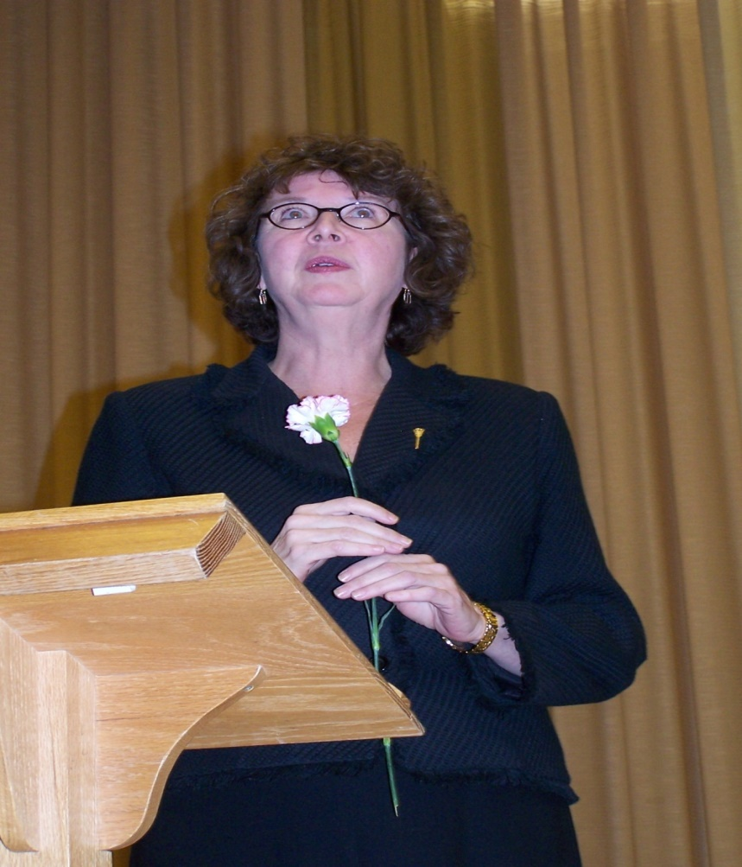

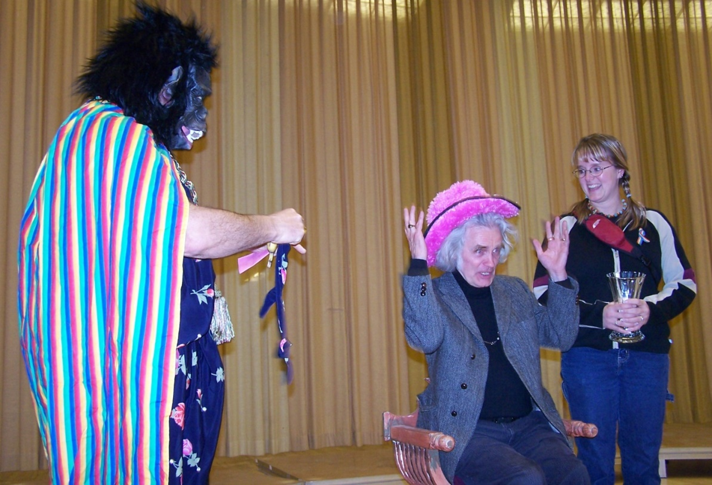

Eight years celebrated by The Bridge City Chorus!

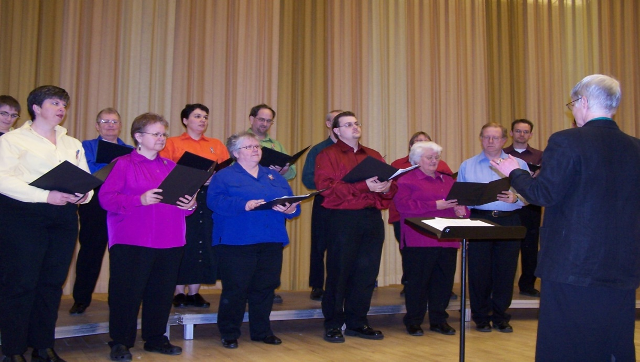

- “Hymn to Freedom”
- “Some of My Best Friends Are Straight”
- “Both Sides Now”
- “Over the Rainbow”

Ninth conference, March 17 and 18, 2006

Conference Theme: “Re-imagining the Possible:

Inspiring Change through the Arts”

Greetings:

Dr. Lea Pennock, from the University of Saskatchewan,

University Secretary, to Dr. Lynda Haverstock, Lieutenant

Governor of Saskatchewan, and to conference participants

Greetings to conference participants:

Her Honour Dr. Lynda Haverstock,

Lieutenant Governor of Saskatchewan

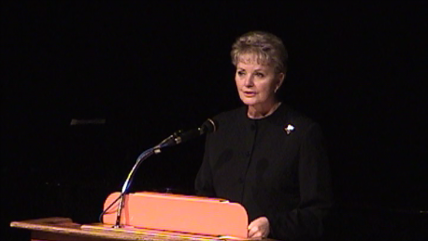

Special Friday-Night Presentation: “Piercing the Thin Skin of Normal: Queer Art and Activism” performed by Shawna Dempsey and Lorri Millan

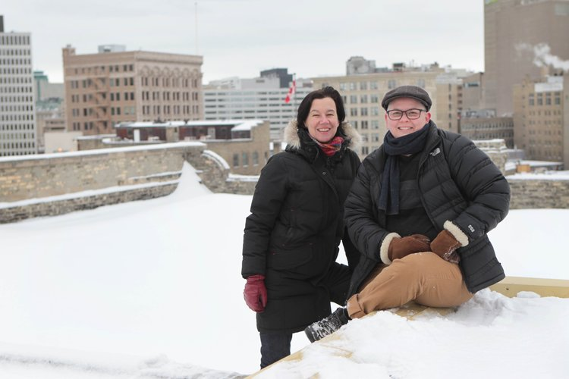

An out-of-uniform photo of Shawna and Lorri, “performance artists” from Winnipeg!

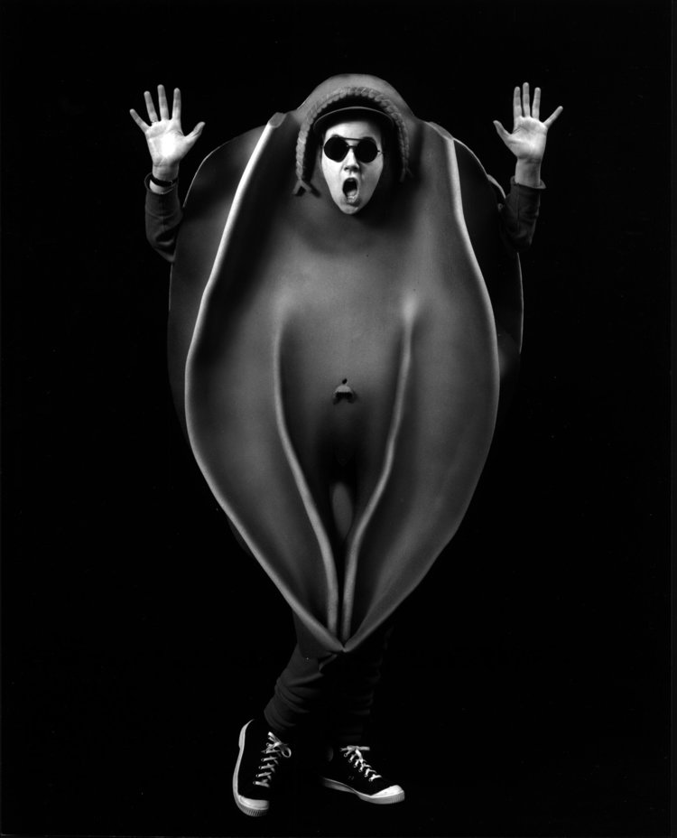
The performance begins with an attractive woman in a dress standing alone and ready to be devoured. She breaks her passivity by launching into a tirade on how fashion – high and low, past and present – oppresses women. Shawna and Lorri offer a withering (and funny) examination of how women are defined and alienated by their bodies.
Saturday morning program

“The road to inclusion: LGBTQ visual narratives of education, community, and culture in Canada, A multi-media presentation” by Kris Wells, University of Alberta

“Q-Theatre: Youth acting, youth activism, a play and workshop” by The Respect for Diversity Youth Troupe

Research report: “Teachers’ perceptions of homophobic behaviour in Saskatchewan secondary schools and their willingness to intervene” by Melanie Morrison and Margi Corbett
Saturday afternoon program
- Wes Pearce, University of Regina, “Fear and loathing in Surrey: Homophobia and The Laramie Project”
- Andre Grace and Kristopher Wells, University of Alberta, “Camp fYrefly: Building resilient youth and inclusive communities”
- Christopher Grignard, University of Alberta, “ ‘The Orchard Drive’: The Okanagan’s first gay play!”
- “Hearing and discussing coming-out stories to friends and parents,” facilitated by Sharon Fyke

“Finding a Home,” a film
“The Invisible Son,” a film, introduced by the director Edward Lee
The Bridge City Chorus:
- “Unchained melody”
- “Time after time”
- “I can’t give you anything but love”

Tenth conference, March 16 and 17, 2007

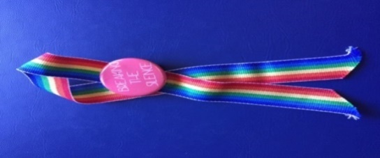
Conference Theme: “We Are at a Watershed: Creating Change through the Arts”

Greetings from the University of Saskatchewan:

A welcome to the Honourable Pat Atkinson by

Dean Cecilia Reynolds, College of Education
Welcome to the Prairie Pride Chorus by Shawna Dempsey and Lorri Millan, queer activists from Winnipeg

Special Friday-Night Presentation:



Watershed Stories performed by the Prairie Pride Chorus of Regina directed by David L. McIntyre

Saturday Morning Program

“Our Lives as Social Activists”

A presentation by Murray and Peter Corren

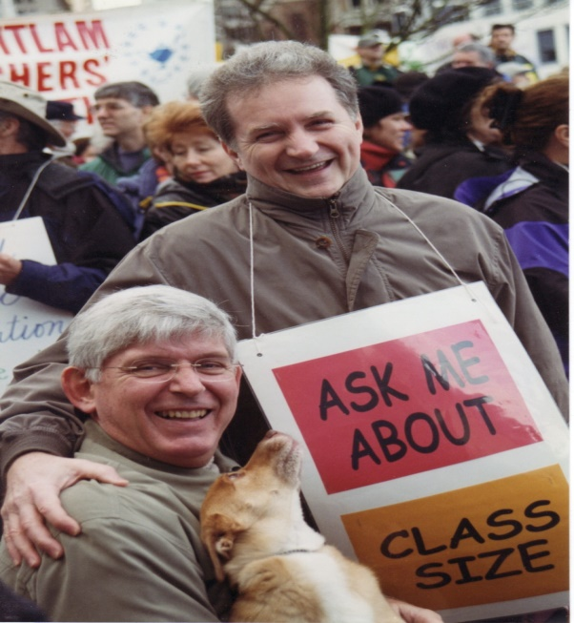

This multi-media presentation gave participants a brief glance into the lives of Murray and Peter Corren, queer advocates for social justice in British Columbia who took on school boards, the social services bureaucracy, and the provincial and the federal governments. They successfully challenged policies and the law and brought about significant changes in adoption, education, and marriage. Through individual, collective, and organizational efforts, this couple achieved advancements in queer education, social services, and Canadian law that will have long-lasting and far-reaching benefits for queers across this country.
Saturday afternoon program

- Kris Wells and Andre Grace, University of Alberta: “Readers’ theatre about three high school students becoming activists”
- Melanie Morrison, University of Saskatchewan: “Prejudice and discrimination experiences of gay men and lesbian women in Saskatchewan: Addressing issues of safety and advocacy”
- Don Cochrane, Jinjie Wang, and Keith Owre, University of Saskatchewan: “Chinese university students’ use of human rights or principled reasons to confront sexual orientation prejudice”
- George Georget and Tim Yee, STF: “What are the critical actions for effective advocacy in the teaching profession?”
- Shawn Sanford Beck, Anglican Church of Canada: “Spirit and sexuality”

Eleventh conference, March 7 and 8, 2008

Conference Theme: “Celebrating Courage: Past and Present”

Greetings from the University of Saskatchewan:

Acting Associate Dean Sheila Carr-Stewart,

College of Education

Greetings from the Government of Saskatchewan:
Deputy Minister Audrey Roadhouse,
Saskatchewan Department of Education

Special Friday-Night Presentation:

A tribute to the “1978 Committee to Defend Doug Wilson”

Chair: Dr. Valerie Korinek,

Department of History, University of Saskatchewan

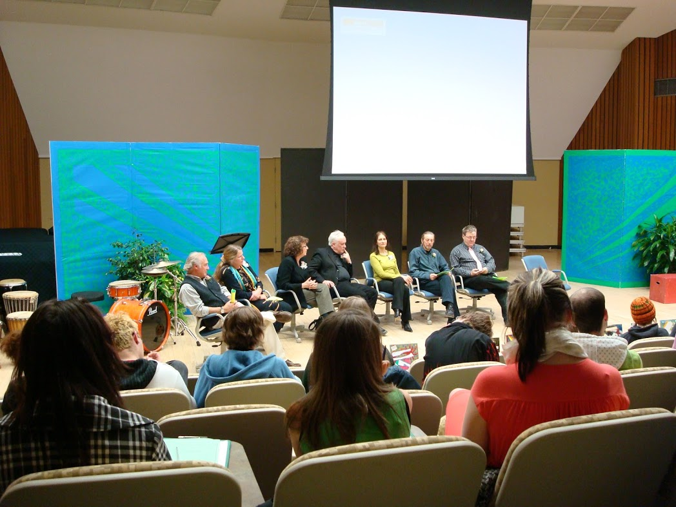Photo by Tom Rogers
Awards of Appreciation presented to members of the Committee to Defend Doug Wilson by Dr. Marilou McPhedran, Chief Commissioner of the Saskatchewan Human Rights Commission and by members of our high-school gay straight alliances.
Saturday morning program
Spirituality, worship, and queer issues: A panel moderated by Michael MacLean, U of S Campus Ministry
- Rev. Anne Marie Nicklin, St. Paul’s Anglican Parish, Biggar
- Rev. Michael Poellet, King of Glory Lutheran Church, Saskatoon
- Fr. André Poilièvre, Priest Moderator, Immaculate Heart of Mary Parish, Martensville
- Laura Fouhse, Diaconal Minister, McClure United Church, Saskatoon
Hate and Bias Crimes, Const. Preston Parranto and Const. Mike McLean, Cultural Resources Unit, Saskatoon Police Service. This session will explore how to recognize, deal with, and report hate and bias crimes.
Saturday afternoon program
- Thom Knutson, Youth Services Coordinator, Saskatoon Public Library (SPL), “Out on the shelves: Recent queer fiction for teens”
- André Grace and Kristopher Wells, Institute for Sexual Minority Studies and Services, Faculty of Education, “Starting a new GSA, keeping it active, and tips for building an LGBTQ inclusive school”
- Don Cochrane and Melanie Morrison, University of Saskatchewan, “How safe and welcoming are Saskatchewan secondary schools for LGBQ youth? A research report on student perceptions”
- Clara Lavery, Coordinator, USSU Pride Centre and Pam Ashburn, USSU Pride Centre Volunteer, “The politics of gender identity”
- Clint Jones Tootoosis, Crystal Saulteaux, and Dale Ahenakew, “The two-spirit tradition: Past, present, and the future”
- André Grace and Kristopher Wells, Institute for Sexual Minority Studies and Services, Faculty of Education, University of Alberta, “Safer schools for sexual minorities: Tips for school administrators and setting up GSAs”
- Bill Prentice and Lynda Oliver, Saskatchewan Ministry of Education, “Seeing ourselves in the curriculum, in the classroom, and in the school community”
- Cantor Neil Schwartz, “Gender issues in Jewish clergy”
- Ali Lake, “Youth-to-youth facilitation!”
- Rev. Shawn Sanford Beck, Anglican Church of Canada, “Tip of the iceberg”

Closing
Arts Extravaganza: Poetry Fusion—GSAs collaborate and create
Organized by Belinda Betker, Bob Birtles, and Cathy Lacey
Aden Bowman Collegiate

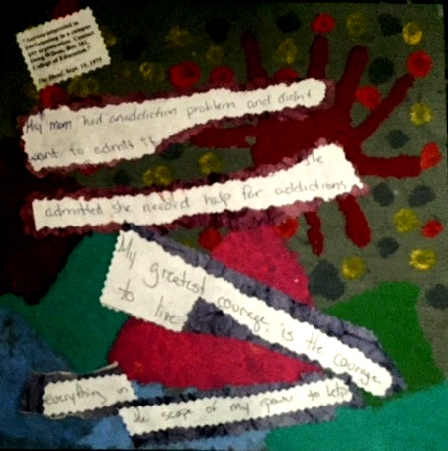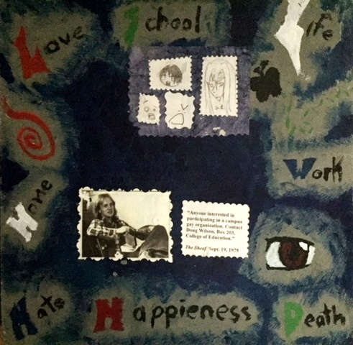
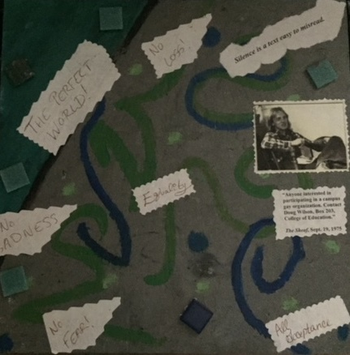

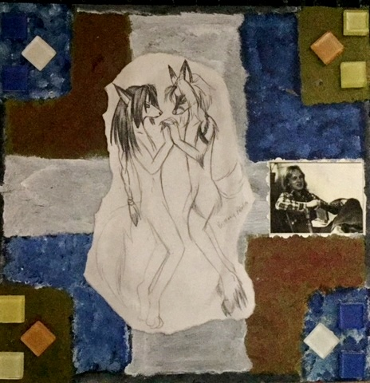
Closing: Bridge City Chorus
- “Hallelujah”
- “Into the West”
- “Troika”
- “What Shall We Do with the Drunken Sailor?”

Twelfth conference, March 13 and 14, 2009

Conference Theme: “Wellness for All”

Greetings from the University of Saskatchewan:

Dr. Vivian Hajnal, Acting Dean, College of Education

Greetings from the Government of Saskatchewan:

Dr. Helen Horsman, Assistant Deputy Minister,

Ministry of Education, Government of Saskatchewan

Special Friday-Night Presentation: Kate Bornstein,

New York performance artist



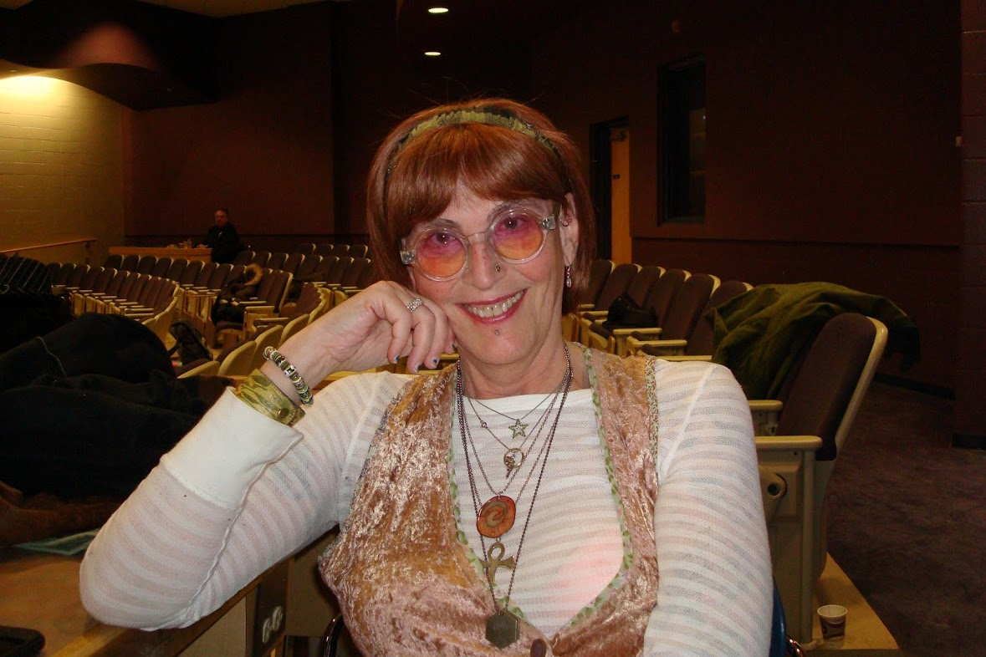Photos by Tom Rogers

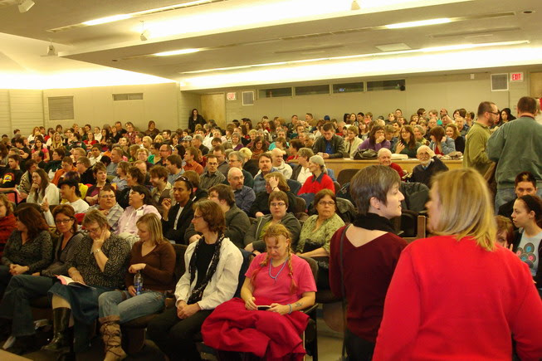

Saturday morning session
- Andre Grace and Kris Wells (U of A), “Camp fYrefly: Where we've been and where we're going”
- “Made unwell by homophobia yet working towards wellness”
- Panel: Emily, a transgender participant, Mike White, a gay educator, and Julie Richards and Nicole White
- Const. Preston Parranto and Const. Mike McLean, Cultural Resources Unit, Saskatoon Police Service on how to recognize, deal with, and report hate and bias crimes.

Saturday afternoon session
- Tonya Callahan, “How homophobia hurts: Psychological and emotional harm to non-heterosexual students and teachers in Canadian Catholic schools”
- U of S Pride Centre, “Unchaining sex and gender, and providing awareness on transgender issues” presented by “Gender Revolution”
- Producer Renée Penney—International Festival Flicks Film Festival: Three short films profiling the lives and realities of queer youth from different countries

- Alex Wilson— Opaskwayak Cree Nation, “Coming in: Aboriginal two-spirit people”
- Gens Hellquist— “Addressing the health and wellness of queer youth”
- U of S Campus Ministry—“For the love of God: Spiritual wellness and pastoral care”
- Jenny Satler— “The process of denial and its effects on wellness for those who vary in gender identity, physical sex, and sexual orientation”
Bridge City Chorus:
- “Lesbians’ Picnic”
- “Dona Nobis”
- “Gender Polka”
Saturday evening session at the Broadway Theatre
Stubblejumper (2008) directed by David Geiss at the Broadway Theatre
In the fall of 1975 at the University of Saskatchewan, Doug Wilson placed an ad in The Sheaf, seeking to start a campus gay group. This seemingly benign action served as the catalyst for a dramatic unfolding of events that shaped the future of Wilson's life. This biographical docudrama is a tale of activism, poetry, performance, politics, and love.
Cured (2008) directed by Courtney T. Gillen
“Gay Away,” a new pill to solve all of the world's problems arrives on the market. One couple feels the pressure to get cured.
March 30, 2009

Cantor Neil Schwartz
Congregation Agudas Israel
715 McKinnon Avenue
Saskatoon, SK S7H 2G2

Dear Cantor Neil,
Let me thank you for providing a certain solemnity to the closing of our Breaking the Silence conference this March. This is the second year that you have offered us the gift of your voice and song. Last year, you blessed us with a song of celebration and this year with a song of healing.
Your presence in both instances has brought a distinctive voice to our proceedings. I personally feel touched that you have taken the initiative to broaden and deepen our experience.
You are now almost a tradition at our conference! Three times, I think, would fully qualify you for this designation! I hope we can count on your making a contribution again next year.

Sincerely,
Don Cochrane
Breaking the Silence

Thirteenth conference, March 22 and 23, 2010

Conference Theme: “Courage, Integrity, and Authenticity in

Public Leadership”

Greetings from the University and a welcome to

The Honorable Scott Brison: Peggy Schmeiser,

University of Saskatchewan, Inter-Governmental

Relations Office

Greetings from the City of Saskatoon: Darren Hill,

Saskatoon City Council

Special Greetings to Scott by video: Svend Robinson

Special Friday-Night Presentation: The Honourable Scott Brison, P.C., M.P. (Kings-Hants)

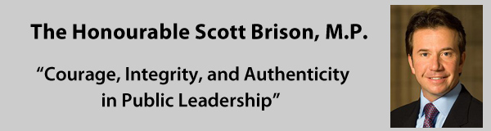

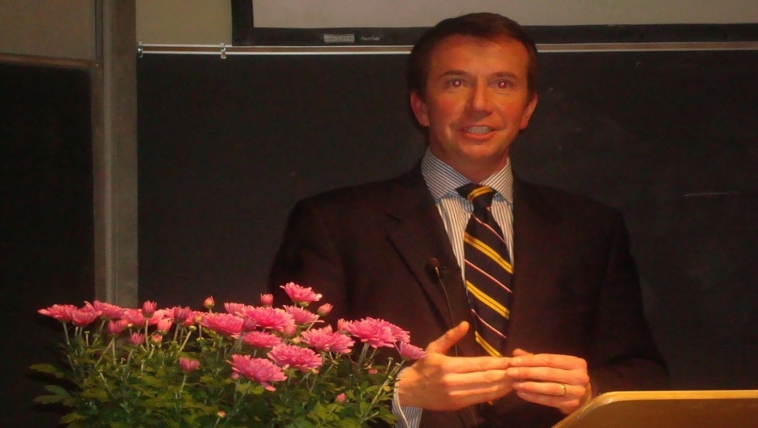

Photo by Tom Rogers
Notes: Until the day before the conference was scheduled to start, we did not know whether Scott’s schedule would permit him to leave Ottawa.

Svend Robinson, who had been an NDP MP and was a friend of Scott’s, sent greetings to Scott by video. In one memorable line, Svend reminded our speaker of advice he had received from Scott several years earlier: “It is not the size of your caucus, but how you use it that counts!”

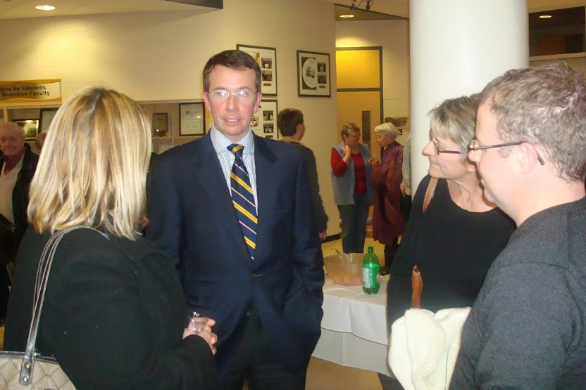

The first Peter Corren Award: Presented to Gens Hellquist, an energetic and dedicated community activist

Gens was an initiator in 1971 of one of the first social clubs for gays in Saskatoon —the Zodiac Friendship Society; in 1983, a founder of a new publication Perceptions; a founder of the Coalition for Human Equality to fight discrimination against sexual minorities; for years, a leader in the struggle to understand and combat AIDS; from 2002, the Executive Director of the Canadian Rainbow Health Coalition; for many years, the Director of the Gay and Lesbian Health Services in Saskatoon (GLHS); and for our first three years, an invaluable member of the Breaking the Silence advisory board.

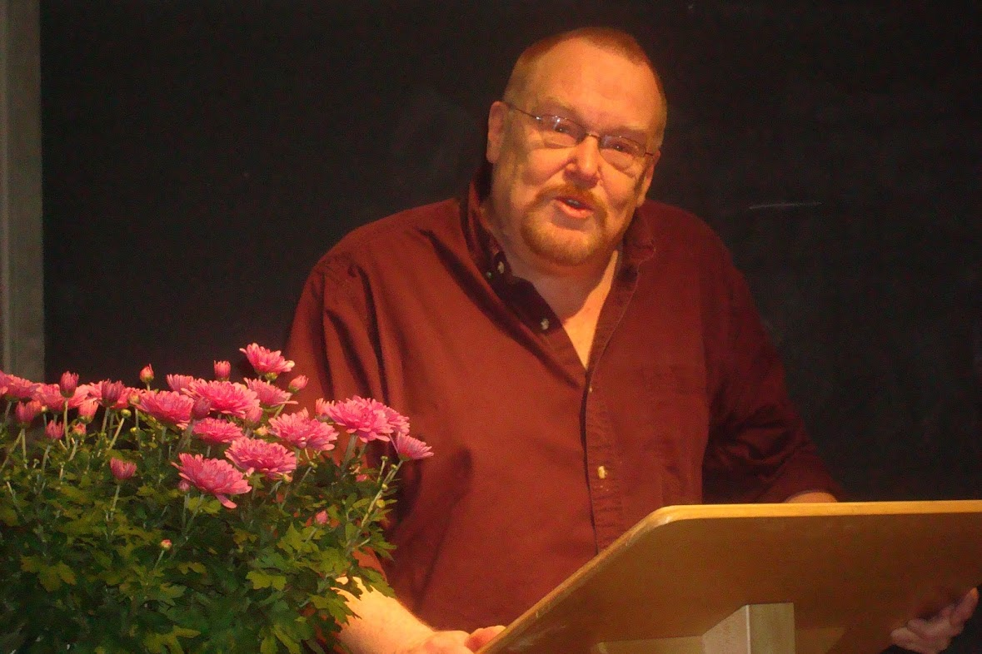

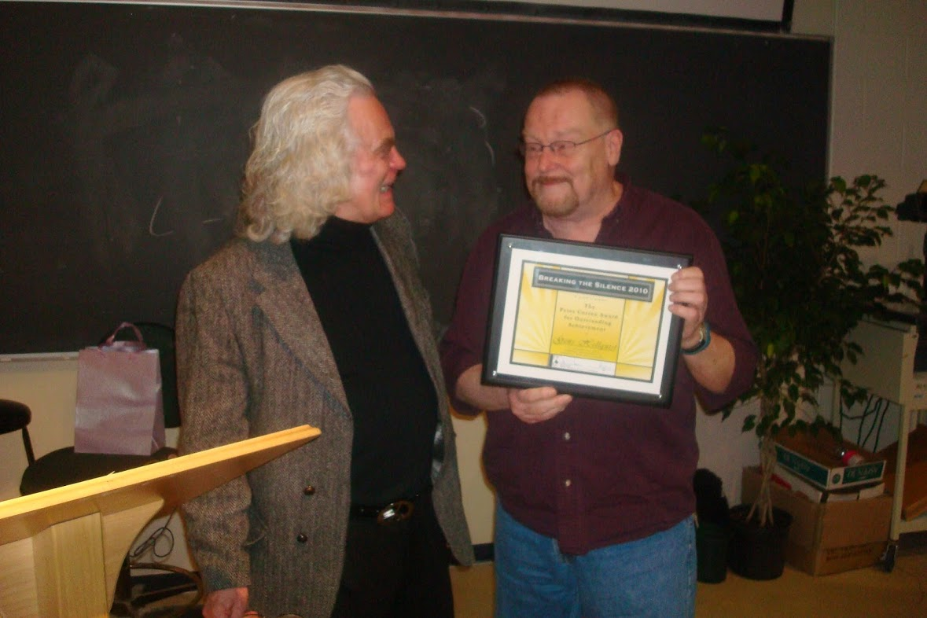

Photos by Tom Rogers

Saturday morning panel: On courage, integrity, and authenticity in public leadership
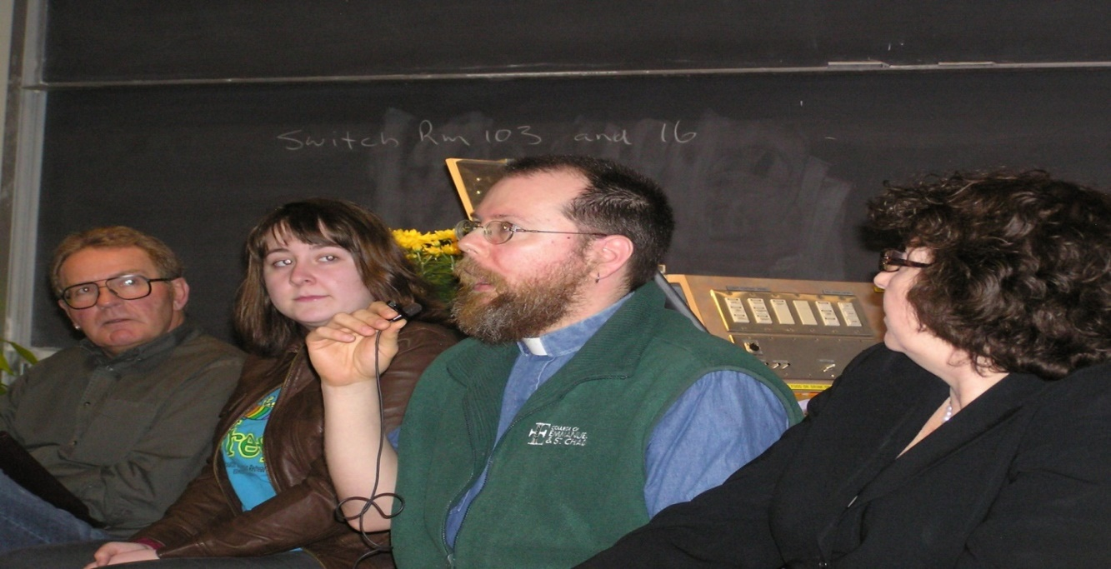

Photos by Tom Rogers
From left to right: Wayne Clements (elementary school vice-principal), Erica McFadden, Camp fYrefly student, Rev. Shawn Sanford-Beck and Pat Atkinson (MLA, Saskatoon Nutana)
Constable Hal Lam (Cultural Resource Officer), Saskatoon Police Service and colleague made a presentation on hate and bias crimes.
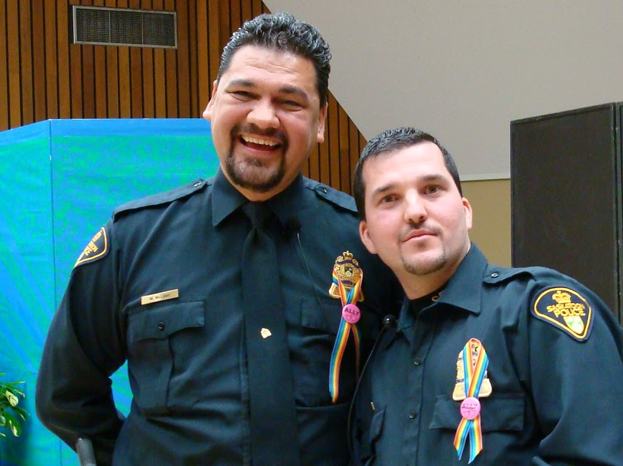

Afternoon program
- Mona Holmlund introduced her Women Together Women Together (Running Press, Philadelphia, 1999)
- Cindie Neudorf, RespectED Trainer for the Beyond the Hurt Workshop—“RespectED: Violence and abuse prevention”
- Sheelah McLean, “Sexy you!(th): 'Buying in' to raunch culture”
- Lisa Jewell, “Subtle discrimination directed toward gay men and lesbian women: What it consists of and how we can address it”
Bridge City Chorus
- “Into the West”
- “He's Got the Whole World in his Hands”
- “Big Dogs, Music” and
- “Wild Wild Women”

Fourteenth conference, March 18 and 19, 2011

Conference Theme: “Confronting the Power and Politics of Exclusion”

Greetings from the University: Dean Cecilia Reynolds,

College of Education

Greetings from Saskatoon: Councillor Darren Hill

Conference Moderator: Nicole White

Special Friday-Night Presentation:

Marci McDonald, “Religion and Politics:

Where in heaven’s name is Canada going?”



Introduction by Dennis Gruending

Response by Peggy Schmeiser

Saturday morning program

Special presentation to Lisa Fedorowich—Don Cochrane and Jane Wollenberg

Pretending that he was a very slow marker, Don “returned” to Lisa, a student in the first “Gay and Lesbian Issues in Education” class, the paper she had submitted in 1997. The quality of that paper immediately sparked the idea of holding a provincial conference so that we could share research of this calibre with a wider public. Jane Wollenberg, a student in that class, joined in making the presentation.

“Exile in the church: Emily Carr and Shawn Sanford Beck share their story”

Peter Corren Award for Outstanding Achievement presented to Neil Richards: librarian, member of the Committee to Defend Doug Wilson, activist, and archivist of materials that document the gay, lesbian, and trans communities in Saskatchewan.

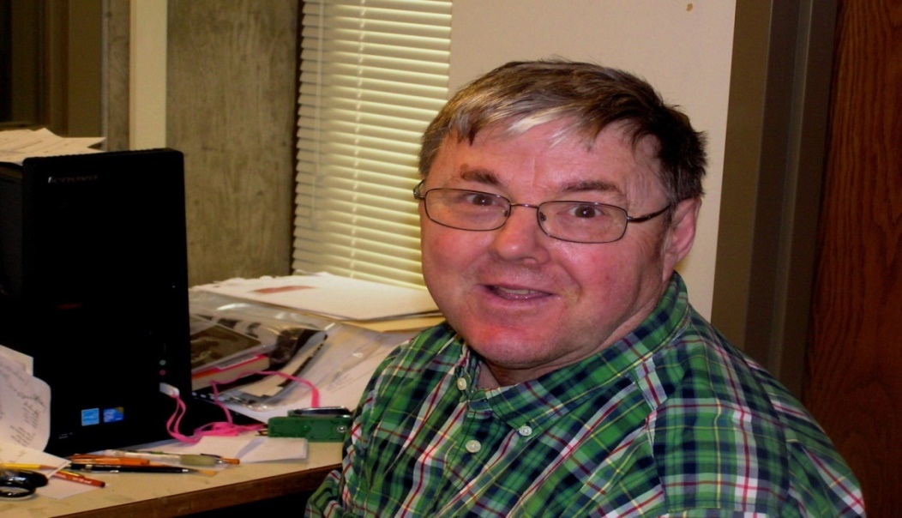

Murray Corren wrote:

“I am so pleased Neil is being honoured this year with the Peter Corren for Outstanding Achievement. I know that Neil has worked tirelessly to build up a unique and valuable archive of queer materials including boxes of evidence from the Surrey Book Banning case. Peter and I knew when we sent those materials to Neil that they would be in very capable and thorough hands.

Congratulations, Neil. Your efforts on behalf of queer people will prove invaluable for decades to come, and I know that I speak for Peter when I say that this award could not have gone to a more dedicated and deserving person.”

Exile in the Church: “Emily Carr and Shawn Sanford Beck shared their story”
Hate and bias crimes: Constable Hal Lam (Cultural Resource Officer), Saskatoon Police Service on how to recognize, deal with, and report hate and bias crimes.
“Camp fYrefly—2010 and 2011” presented by James McNinch, Toby-Dawne Smith, and Anthony Santoro

Saturday afternoon program
- Peggy Schmeiser and Dennis Gruending—“A conversation with Marci McDonald”
- Jai Richards, “Giving voice to the trans community: A Saskatchewan perspective”
- Jen Green, “The experiences of lesbian teachers in Saskatchewan schools
- Deanne McKenney (professional educator), Eric Twa (university student), and Sarah (high school student), “Three different stories about how it got better: Opening a conversation”
- Carla Blakley, “Que(e)r(y)ing the image of God”
- Zakaery Gudmundson, “Human rights and the transgender individual”
- Sheelah McLean, “The hetero-patriarchal gaze: A capitalist story”
- Andre Grace: “Helping sexual minority and gender variant youth to grow into resilience”

Closing: Cantor Neil Schwartz introduced us to a new Jewish GLBT prayer

Bridge City Chorus
- “Light a Candle” by Marta Keen
- “Four Strong Winds” by Ian Tyson
- “Breaths” by Yasye M. Barnwell
- “Parade” by Eric Lane Barnes

Fifteenth conference, March 16 and 17, 2012

Conference Theme: “Telling our Stories—Making Lives Better”

Greetings from the University of Saskatchewan:

Richard Florizone, Vice-President of Finance and Resources

Greetings from Saskatoon: City Councillor, Charlie Clark

Introducing Ivan Coyote: Keegan Epp, Pride Center Coordinator, USSU

Special Friday-Night Presentation: Ivan Coyote, writer and storyteller extraordinaire

Thank You: Sarah Houghtaling, high school activist, Swift Current

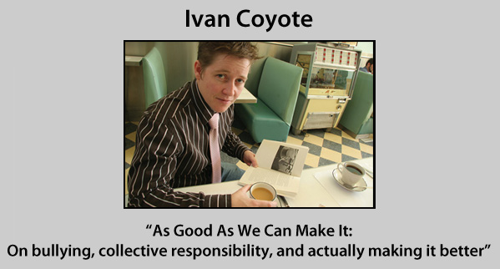

Saturday morning program

A two-spirit panel with Dr. Alex Wilson and panelists: Ryan Jimmy, Jack Saddleback, and Marjorie Beaucage

The Camp fYrefly video, Herb McFaull and Tony Bidulka

Emily Carr and Shawn Sanford Beck, “One year later”

Sarah York and Marie Lovrod, Creating a work based on the Neil Richards collections

The Peter Corren Award for Outstanding Achievement, presented by Don Cochrane to Kay Williams, activist in many progressive causes, member of the national board of directors for PFLAG beginning in 2004, co-founder of the PFLAG-Saskatoon, and member of the Breaking the Silence advisory board since 1997.

Saturday afternoon program
- Russell Mitchell-Walker, “Camp fYrefly: Year Four”
- Tonya Callaghan, “Law and disorder: Sexual minority rights in Canadian Catholic schools”
- Gens Hellquist, “Homophobia is killing us: How our institutions are failing queer people”
- Jim Drake, “Only you can tell your story”
- Kyle Schwartz, “Coming out and staying healthy”
- Tonya Callaghan, “Law and disorder: Sexual minority rights in Canadian Catholic schools”
- Jai Richards and Sean Hellquist, “Trans101–An intro and a conversation”
- Nicole White, Gens Hellquist and Paul McDermid, “It's in you to give” (on the effects of the Canadian Blood Services blood ban)
- Jenna Blahay and Kyle Schwartz, “A roundtable discussion on starting and sustaining a vital and exciting GSA”
- Kyle Schwartz, “Coming out and staying healthy”
- Rebekah Bennetch, “Out(side) spirituality for secular humanists”
- Tobi-Dawne Smith, “Sex, gender, and how the heck do I fit into it all?”
- “Fallout and the follow-up of sexual diversity,” Three personal stories: A queer youth, Sara; a parent of queer youth, Fran; and a queer parent, Valerie
- Shawn Sanford Beck and Emily Carr, “A spirituality sharing circle”

Bridge City Chorus sang us out!
- Hard Times Come Again No More (Traditional)
- Gay vs. Straight Composers (Eric Lane Barnes)
- Halleluia (Leonard Cohen)

Sixteenth conference, March 22 and 23, 2013

At the Broadway Theatre

Conference Theme: “Clearing it out: Removing Homophobia

from the Locker Room and Beyond”

Greetings from Dr. Ilene Busch-Vishniac, President,

University of Saskatchewan

Greetings from Avon Whittle, Director of Education, Saskatoon Public Board of Education

MC: Linda Walker, Sports Reporter, Global TV

Recorded greetings from Mark Tewksbury and
Patrick Burke (“If you can play, you can play”)

Special Friday-Night Presentation: Jon Cornish, Calgary Stampeders

“This Is My Story”

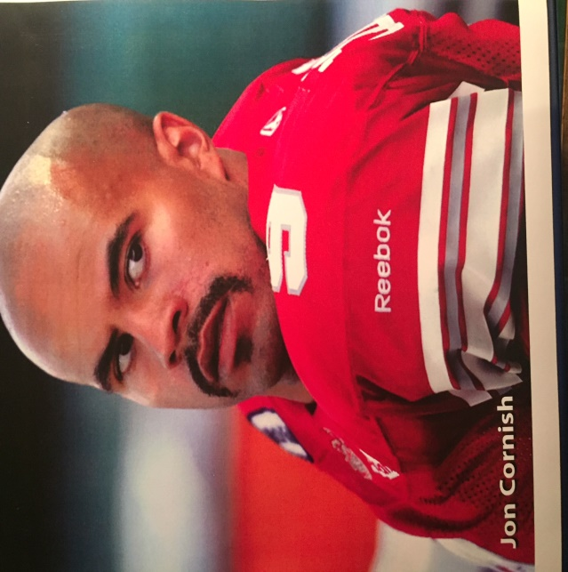

Photos by Tobi-Dawne Smith

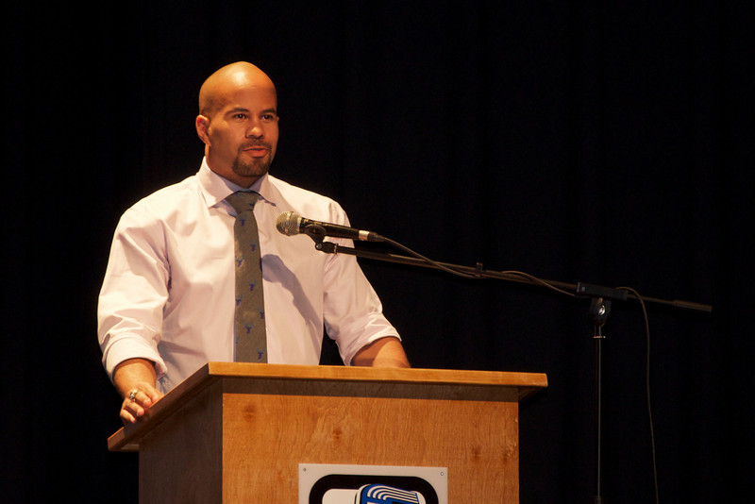

Jon Cornish addresses the conference.

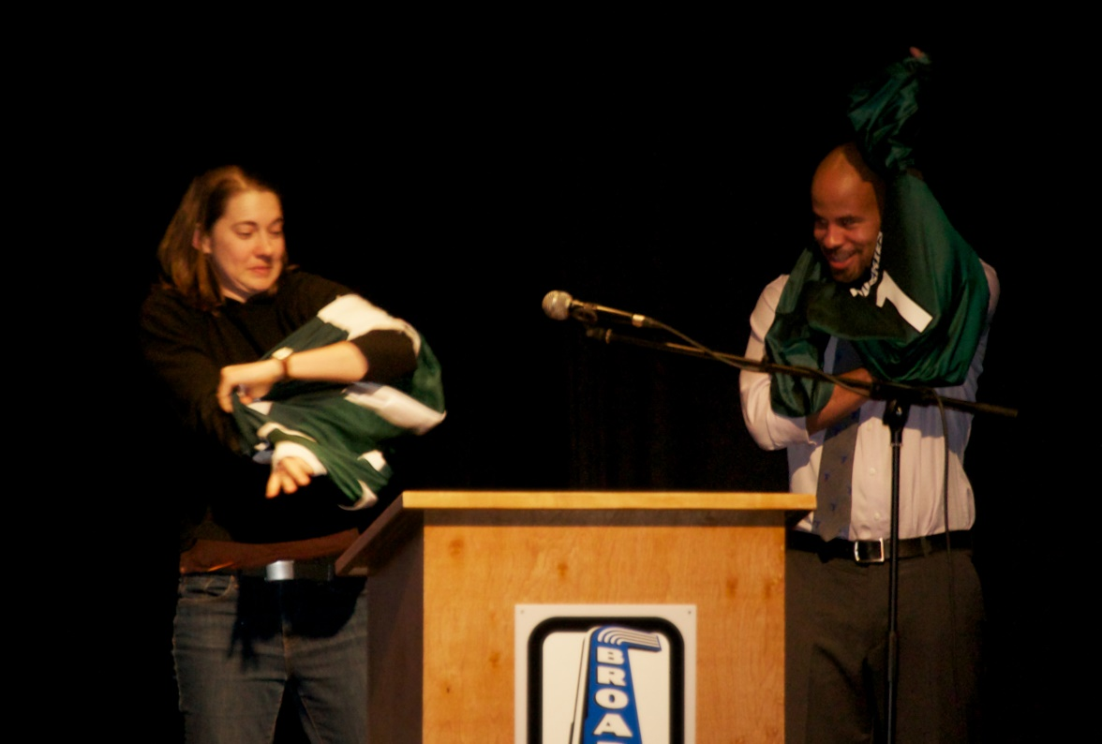

Candace Bloomquist, quarterback of the Saskatoon Valkyries, thanks Jon and makes him an honorary Huskie!

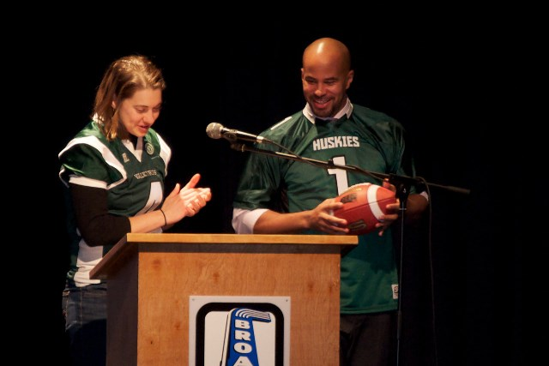

Candace reviews the playbook with Jon!

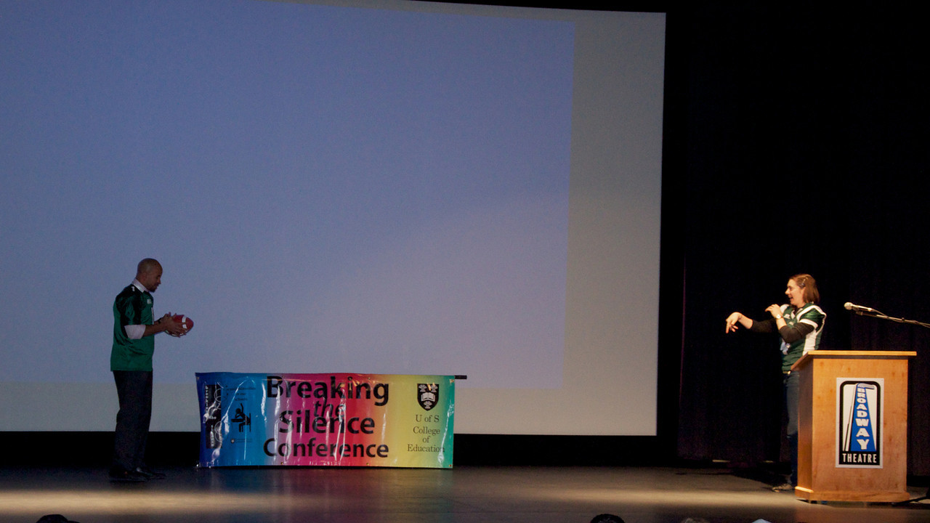

Jon tries out for the Valkyries, runs a hook pattern, catches a hard toss from Candace, and she decides that he can make the team!

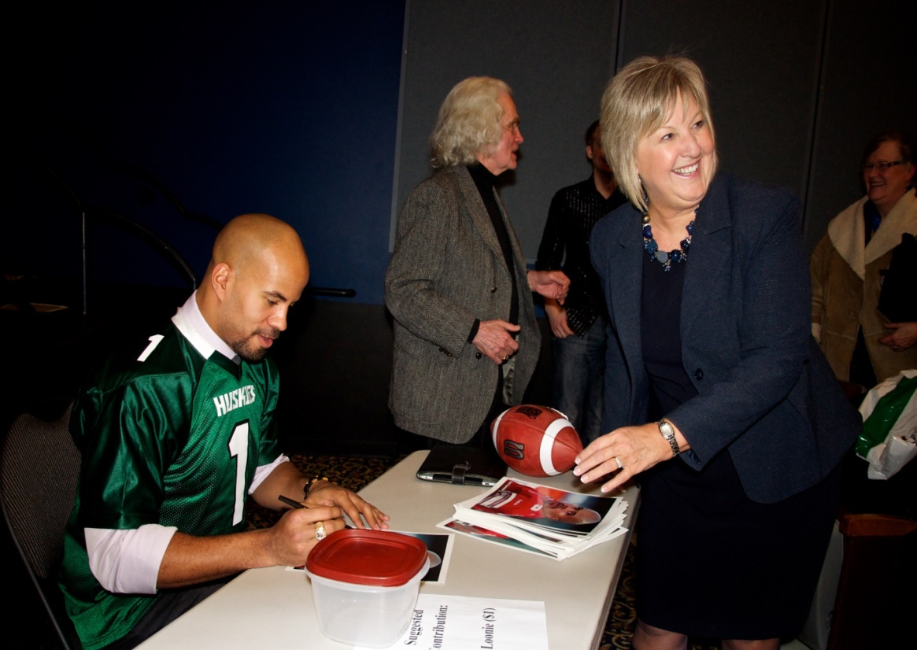

Jon signs his photo for Avon Whittle, Director of Education, Saskatoon Public Board of Education

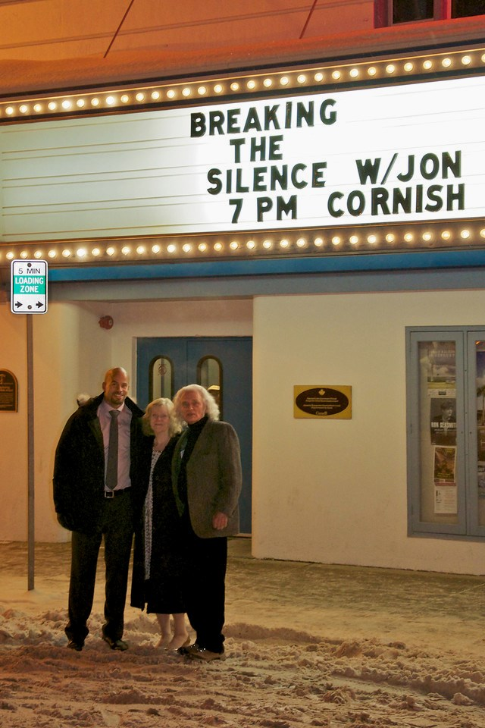

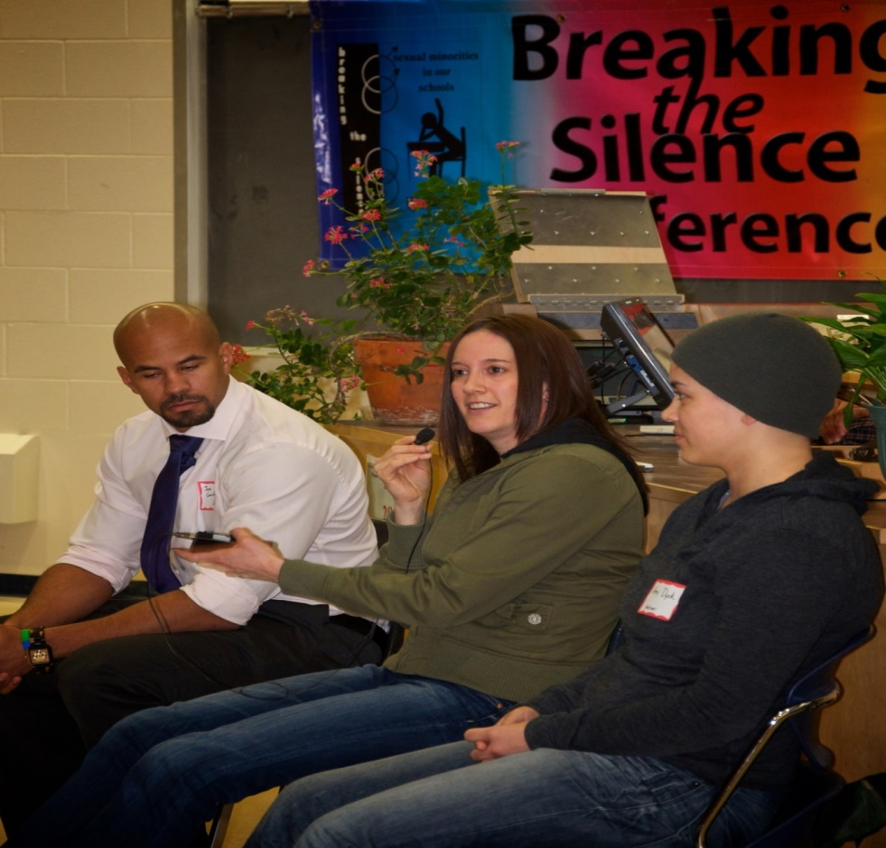

Our Saturday morning panel: Jon Cornish, running back for the Calgary Stampeders; Jaqueline Lavallee, Huskie three-time all-star basketball and soccer player; and Amy Dyck, three-time CIS Huskie wrestling medallist.

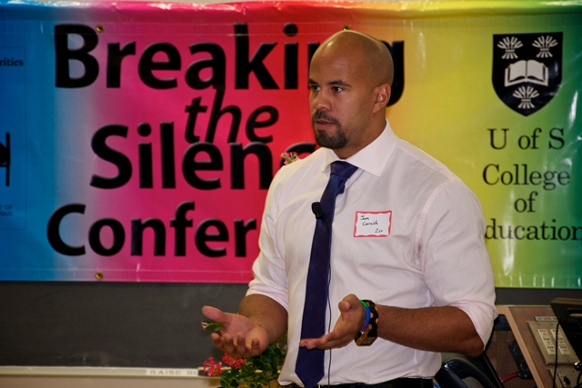

Peter Corren Award presented to Jim Komar

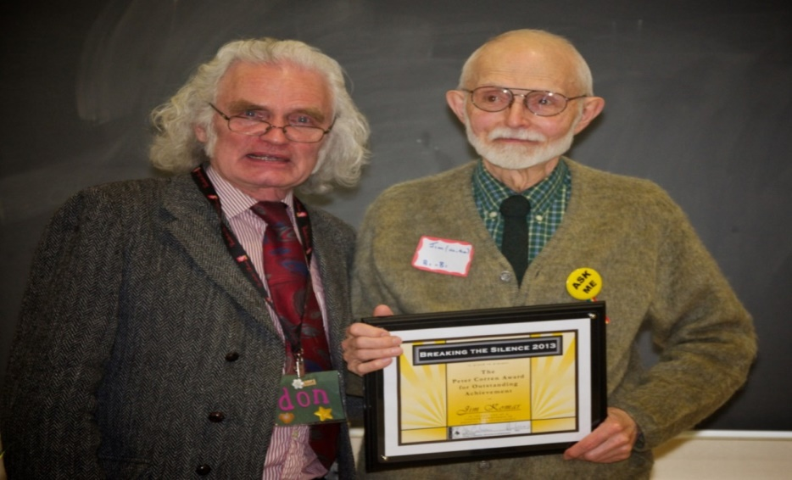

Jim Komar was a long-time activist for sexual minority rights. He was a charter member of Affirm United at Grosvenor Park United Church and Integrity, an Anglican Church support group, an eight-year member of PFLAG, and an official complainant to the Saskatchewan Human Rights Commission more than ten years ago regarding hate speech and the anti-gay activities of William Whatcott (a case that led to the landmark judgment by the Supreme Court of Canada in 2013).

Peter Corren Award presented to Patty Rowley

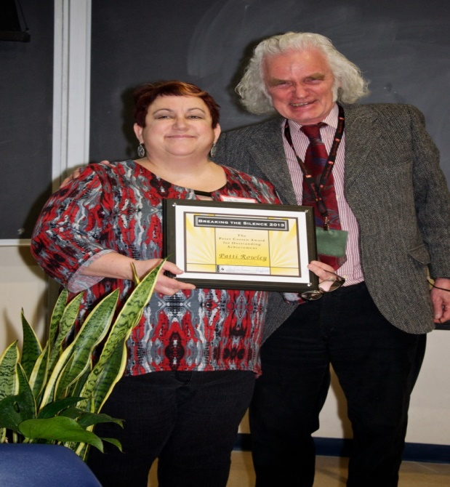
Patti Rowley was the teacher-liaison for the first Gay-Straight Alliance in a Saskatchewan high school and has led vibrant groups for eighteen consecutive years in Saskatoon. Her commitment to social justice for sexual minority students is deep; her resolve has been consistent; her activism, persistent; her joy in her activity, infectious. She is a model for her students and a challenge to us all. She has taught us that one person can make a difference in their world wherever it is.
Saturday morning program
Judge David M. Arnot, Chief Commissioner, Saskatchewan Human Rights Commission, “Hate Speech: The Supreme Court of Canada’s Decisive Decision”:

On February 27, 2013, the Supreme Court of Canada rendered a unanimous decision, which found that two flyers distributed by William Whatcott contained statements which tended to expose a group of persons to hatred contrary to s. 14 of The Saskatchewan Human Rights Code. The court unanimously recognized the importance of prohibitions on public expressions of hate in protecting vulnerable groups from discrimination.

Saturday afternoon program
- Don Cochrane, “Turning the tide: Athletes standing up for sexual minorities in sports”
- Fran Forsberg, “Inspired parent: Shared vision of creating a world of normal for gender creative and transgender children”
- The Reverend Margaret Cornish, “Conversations with Margaret Cornish”
- Jack Saddleback, Pride Centre Coordinator led participants through gender/sexual diversity and Aboriginal terminology in Canada
- Tobi-Dawne Smith – “Sex, gender, and how the heck do I fit into it all?”
- Angela Reid (Edmonton), a member of the “Oil City Derby Girls” and Sarah Mathiason (Saskatoon), President of the Saskatoon Roller Derby League: “Rolling 'out': Roller derby sets a new standard for transgender inclusiveness”
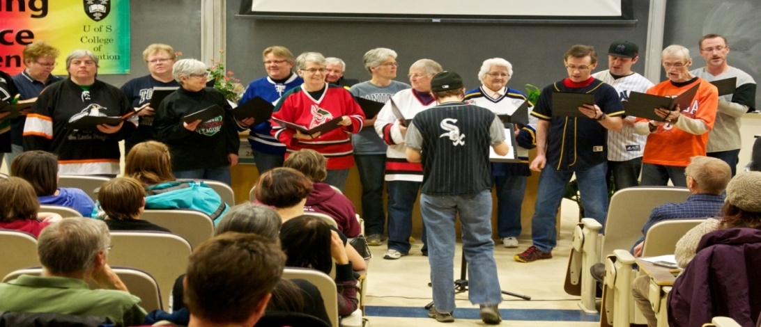

The Bridge City Chorus “sang us out” with three songs: “Let Me Play in the Ball Game,” “Queer Songs on Common Themes,” and Lady Gaga's “Born this Way”
Saturday Evening
Movie Night: “Training Rules”—Neatby-Timlin Lecture Theatre, Arts Building, U of S Campus. The discussion was led by Jill Humbert, Interim Coach of the Women’s Huskie Basketball Team, and Candace Bloomquist, former NCAA basketball player with Creighton University’s Women’s Basketball Team.
Sunday Morning
Worship Service, St. Andrew's College chapel led by Michael MacLean, Emily Carr, Lorraine Harkness, Trisha Little, and special guest, The Rev. Margaret Cornish

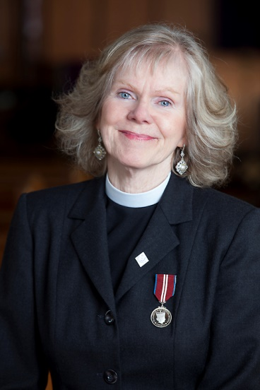

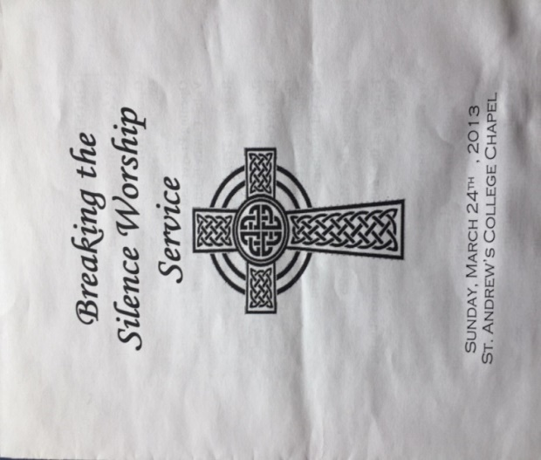

Seventeenth conference, March 21 and 22, 2014

Conference Theme: “Speaking Out: Performing Solidarity”

Greetings from the University of Saskatchewan:

Dave Hannah, Associate V-P Student Affairs

Greetings from David Forbes:

Saskatoon Centre MLA and LGBT advocate

MC: Jeff Rogstad, Co-host of the noon news and CTV Saskatoon's weatherman
Welcome to Treaty Six Land: Dion L. J. Tootoosis, Aboriginal Languages and Cultural Coordinator, Indian Teacher Education Program, University of Saskatchewan
- Special greetings from Jon Cornish, a friend of the conference!
- Introducing Elvira Kurt: Marcel Petite, visual artist
Elvira Kurt, our Special Friday night presenter, delivered a wonderfully outrageous performance



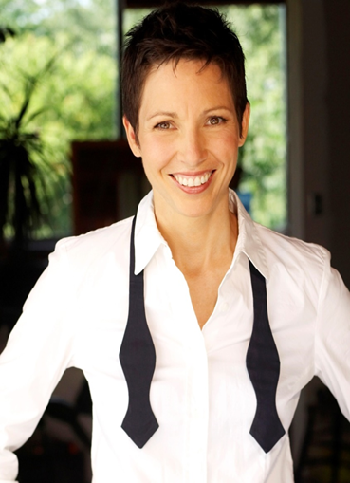

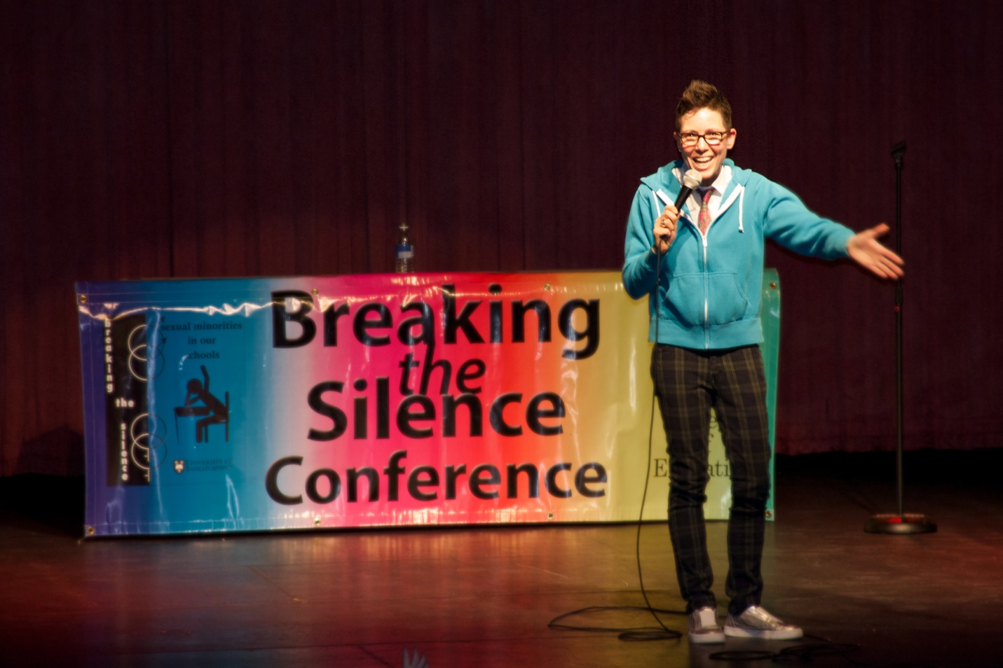
Thank You: Rachel Loewen Walker, Executive Director of the Avenue Community Centre

Saturday morning program
The director Charlie Peters—a Breaking the Silence and an Aden Bowman GSA Alumni—and Chris Donlevy, one of the performers introduced the play Stop Kiss by Diana Son that was performed at The Refinery Arts & Spirit Centre, March 27-April 6, 2014.
A Panel on inclusion: Creating safe, caring, and accepting schools—Where are we now? Where do we need to be? How do we get there?
- The voices of high school students
- Jennifer Campeau, MLA, Saskatoon Fairview and Legislative Secretary to the Minister of Education for the Anti-Bullying Initiative
- Kyla Christiansen, Comprehensive School Community Health Consultant, Saskatchewan Ministry of Education
- Pam Goulden-McLeod, Safe and Caring Schools Consultant, Saskatoon Public Schools
- Chandra McIvor, Youth Development and Education, Avenue Community Centre, Saskatoon
- Fran Forsberg, a parent
The Peter Corren Award for Outstanding Achievement: Presented to Don Cochrane who developed the undergraduate course Gay and Lesbian Issues in Education in 1995—the first course in the history of the university to be devoted exclusively to sexual orientation issues. Don founded the Breaking the Silence Conference in 1998 and has been its chief organizer since that time.
Saturday afternoon program
- The Sakewew Gay-Straight-Alliance, North Battleford, a student-led and organized, non-curricular school group aims to create a safe, welcoming, and accepting school environment for all youth and staff regardless of sexual orientation or gender identity.
- Understanding asexuality—Bailey Lindsay, Chance Briere, and Liz Senecal
- Gender and sexual diversity 101
- Trans issues—Sean Hellquist and Jai Richards.
- Breaking the silence within churches—Carla Blakley
- A Camp fYrefly retrospective—Andre Grace
- How to become better activists—Nicole White and Amanda Guthrie
- Greystone Secrets: A queerstorical campus scavenger hunt—Joe Wickenhauser
- Trans issues—Sean Hellquist and Jai Richards
- How to become a strong parent advocate—Fran Forsberg
- A GSA exchange on best practices—Leanne Kadyschuk (Bedford Road), Patti Rowley (Walter Murray), Travis Myrol (Walter Murray), and Vicki Summerfeldt, Evan Hardy
Spoken Word Poetry introduced by Danielle Altrogge and featuring Meg Land, Caragana Ennis, and Khodi Dill and accompanied by jazz pianist Ray Stephanson

Saturday evening movie My Prairie Home (an intimate portrait of transgender singer Rae Spoon)
Sunday morning Worship service, St. Andrew's College Chapel led by young adults of Sanctuary Saskatoon—a Christian-based support group for the GLBTQ community in Saskatoon.

Eighteenth conference, March 21, 2015

Conference Theme: “Vision without action is just a dream,” Li Yinhe

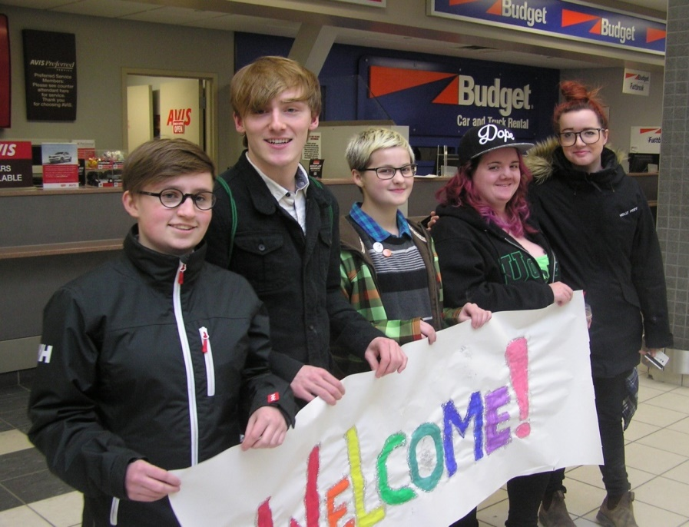

Moderator: Patti Rowley

Saturday morning program
Presentation by seven Vancouver high-school activists: “Updating LGBTQ School Policies: Lessons from Vancouver” featuring Kate Fry, Roisin O'Dwyer, Violet Read, Cory Oskam, Meghan French-Smith, Andy Legge, and Jacky Jiang
Introduced by Lindsay Herriot and Mimi Mahovlich
(We gratefully acknowledged financial support from the Corren Foundation that made this presentation possible.)

Peter Corren Award for outstanding achievement introduced by Don Cochrane and presented by Dave Little to Pat Atkinson.

When an undergraduate student in the College of Education, she was an active member of the 1975 Committee to Defend Doug Wilson. As a member of the provincial cabinet in 1993, she was a advocated vigorously for revisions to Saskatchewan Human Rights Code that made it illegal to discriminate against a person on grounds of “sexual orientation.” As Minister of Education, she addressed the first Breaking the Silence conference in 1998 decrying discrimination in schools based on sexual orientation.

The persecution of LGBT people around the world—Helen Smith-McIntyre and Bill Rafoss, Amnesty International

Saturday afternoon program
- Trans families and their challenges, Fran Forsberg
- Lavender pilgrims: Turning the tide in churches, Jim Komar, Marc Trottier, and Barb Clay
- Meet some of our Vancouver high school activists
- Thinking beyond LGB: Understanding asexuality, Maaya Kuri Hitomi
- An LGBT 101 discussion of school washroom issues, Amanda Guthrie
- Picture books: Our community, our children, A guide for parents, teachers, and caregivers, Tobi-Dawne Smith
- Intersex identities, Leo Keiser
- How to be an activist, Nicole White and Amanda Guthrie
- Hidden histories: Gender & sexual diversity in Saskatchewan, Joe Wickenhauser
- How to start a GSA, Leanne Kadyschuk
Spoken word poetry—Introduced by Elly-Jean Nielsen and Amanda Guthrie and featuring Ryan Bradshaw, Meg Land, and Chance Briere

Nineteenth conference, March 4 and 5, 2016

Conference Theme: “To thine own self be true!” Shakespeare,

Hamlet, Act One

Special Friday-Night Presentation: A showing of Gen Silent

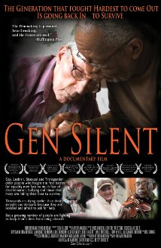
Gen Silent—This documentary follows the lives of six LGBT seniors living in the Boston area who must choose whether or not to hide their sexuality in order to survive in the long-term health-care system. For TV coverage, see <https://globalnews.ca/news/2559438/lgbt-seniors-worry-about-reitrement-housing/>.
Moderator: Elly-Jean Nielsen
A conversation with Cheryl Loadman, senior author of Gay, lesbian, bisexual and transgender (LGBT) older adults and residential care environments – Final Report (2016) which examines the challenges faced by LGBT older adults within residential care environment in Saskatoon facilities, and Ashley Heaslip, a family doctor in Vancouver and PhD student at UBC where she is working on a project titled “LGTBQ elders and residential care: Experiences of isolation and resilience explored through art and dialogue.”
Saturday morning
Moderator: Laura Negraeff
A presenatation by Fran Forsberg and the “Caterpillars”—“Transitioning ... Society and Ourselves! Stories from Camp Caterpillar and Beyond” and Huskies Athletics launched their “You Can Play” video!
The Peter Corren Award introduced by Don Cochrane and presented by Joe Wickenhauser to Alex Wilson
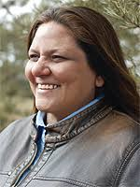
Alex's ground-breaking work on the identity development of two-spirit people is recognized internationally and has become a touchstone for many LGBTQI Indigenous people. Her scholarship has greatly contributed to building and sharing knowledge about two-spirit identity, history, and teachings; Indigenous research methodologies; and the prevention of violence in the lives of Indigenous peoples. Her current projects include research into two-spirit and Indigenous feminisms, two-spirit identity development, “Coming In” theory that impacts pedagogy and educational policy, and working with the Aboriginal HIV/AIDS Community-Based Research Program.

“Good News,” Huskies Athletics launched its “You Can Play” video!

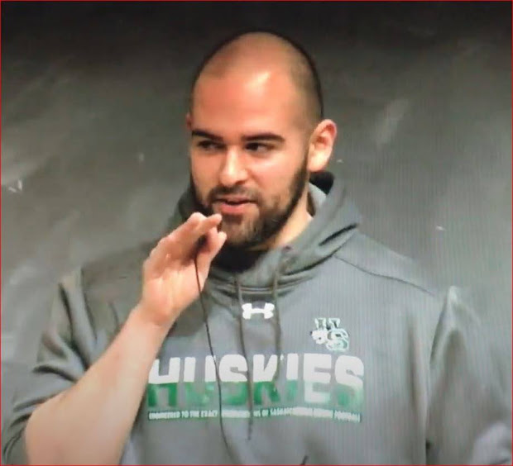
Josh Butcher, all-star football lineman, introduced the University of Saskatchewan’s “You Can Play” video on behalf of Huskie Athletics. Director Basil Hughton launched the video along with Steve Kook, Women’s Hockey Coach, and players Caitlin Willoughby, Kori Herner, and Rachel Lundberg, and from Women’s Volleyball, Emily Humbert, and Marg Ferguson, and Daniel Herrick who organized coaches and athletes for the video. click on https://www.youcanplayproject.org/video/you-can-play-university-of-saskatchewan/
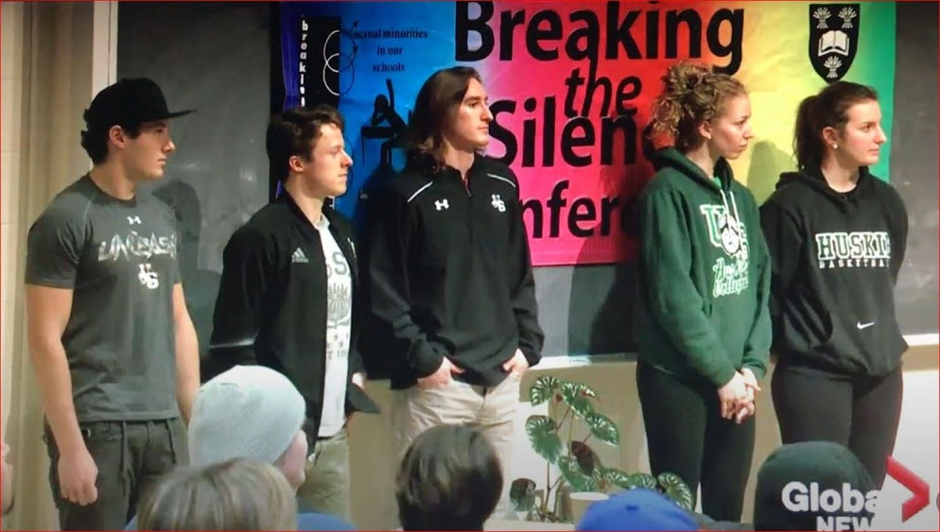

Saturday afternoon program
Our workshops:
- Creating safe spaces: A panel discussion on positive changes in Saskatoon schools, Amanda Guthrie
- What teachers need to know, Marla Daigneault
- Starting a GSA in a rural school division, Mark Perry and Sarah Gerrard
- A further conversation with Cheryl Loadman and Ashley Heaslip
- Telling our stories: What I have learned and what I want to learn, Kay Williams
- Medical transitions 101: Dr. Leane Bettin talks hormones and blockers
- Keeping trans communities healthy: A social approach, Maaya Hitomi
- Surviving to thriving: The hard conversations from the point of view of a suicide survivor and transgender lesbian, Laura Budd
The Return of Our Spoken Word Poets!
Caragana Ennis, Meg Land, D'j and Chance Briere

Twentieth conference, March 17 and 18, 2017

Conference Theme: “Looking Back, Moving Forward”

Greetings from the University of Saskatchewan:

President Peter Stoicheff

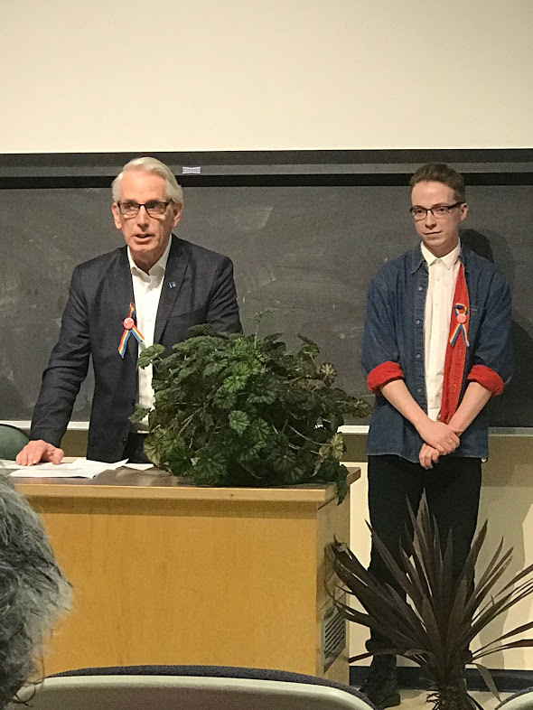

Greetings from the City: Mr. Charlie Clark, Mayor of Saskatoon

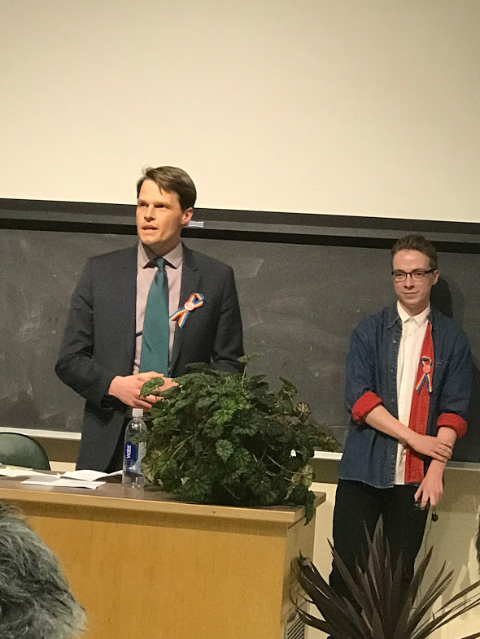 Photos by Tom Rogers

Special Friday-Night presentation: A performance of The Pink Unicorn



Cast: Kristi Friday as Trisha Lee

Director/Designer: Aaron Hursh

Stage Manager – Emma Thorpe

The Pink Unicorn is a play in which a Christian widow tells her story of living in a conservative Texas town. Her life is thrown into turmoil when her teenaged daughter announces that she is “gender queer.” Trish goes on a rampage and starts a chapter of the Gay and Straight Alliance at the local high school. What follows is both heartbreaking and very funny. It is a comedy and so good triumphs over evil!

Saturday morning program

Moderator: Margi Corbett

Don Cochrane, “Celebrating Murray and Peter Corren: Activists in Pursuit of Justice” and presentation of the 2017 Peter Corren Award to Fran Forsberg and to Tony Bidulka and Herb McFaull.

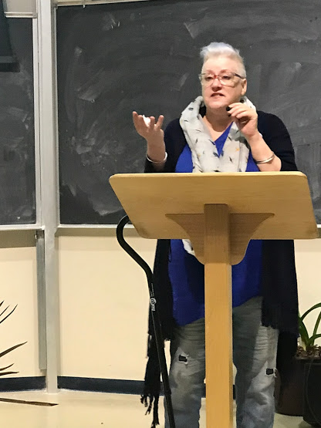

Fran Forsberg receiving the Peter Corren Award

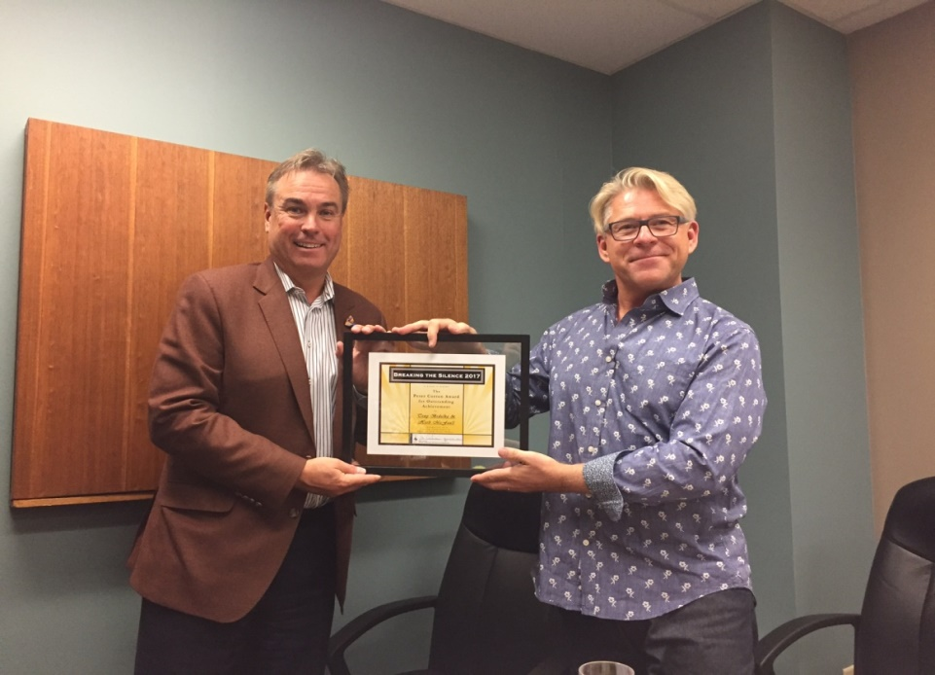

Herb McFaull and Tony Bedulka receiving their Peter Corren Award

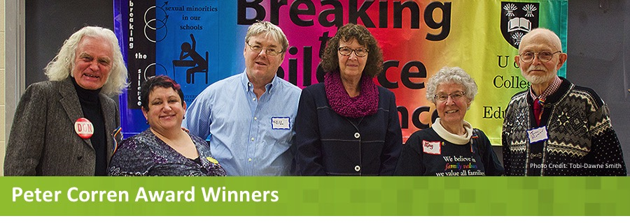

Don Cochrane (2014), Patty Rowley (2013), Neil Richards (2011), Pat Atkinson (2015), Kay Williams (2012), and Jim Komar (2013)

Sheri Benson, MP for Saskatoon West, and Larry Kowalchuk, a human rights lawyer, challenged us to “look back and move forward.”

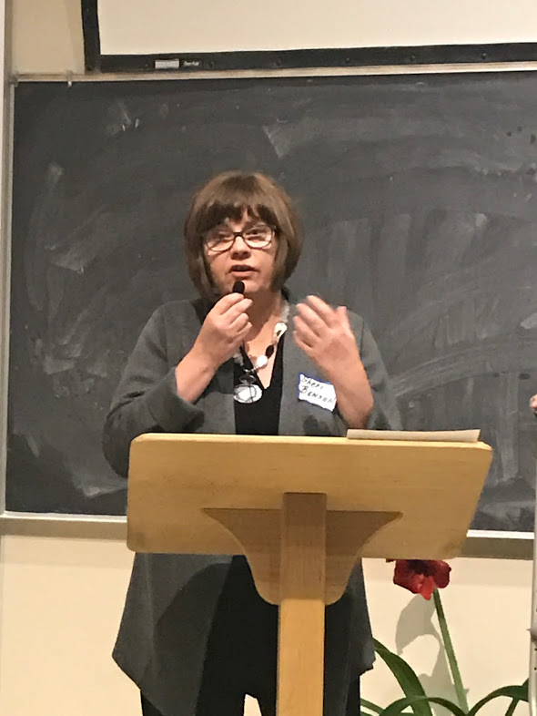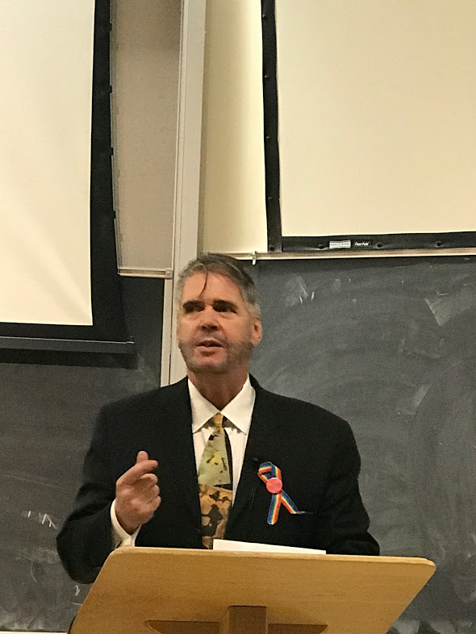

Afternoon Program

Helen Smith-McIntyre, David Feick (Micah Mission), Jim Komar (gay Christian activist), and a special participant, “Breaking the silence on LGBT issues in prisons”

Mark Perry and Sarah Gerrard, “Starting a GSA in a rural school division”

Emily Coates, A member of the Youth Community Counselling team, Saskatoon Health Region. “Working with transgender children and youth and mental health”

Jessica McCutcheon with Melanie Morrison, “Has prejudice against LGBT persons declined?”

Ryan Willey read extracts from his new book Becoming the Devil They Fear: A Gay Book of Shadows.

Emily Coates, “Working with transgender children and youth and mental health”

Closing:

Our Spoken Words Poets featuring Ky Mason Lapointe, Elise P., Danielle Altrogge, and Larry Kowalchuk.

China White and Iona Whipp, “The Art of Drag: The act of self-expression and the history and culture of our empire”

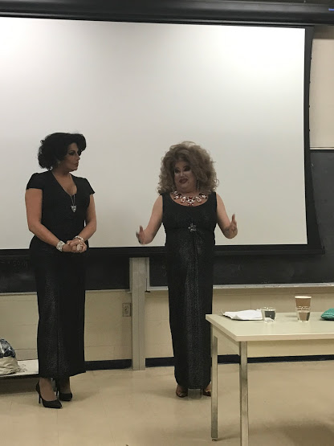

Closing – We joined Karen Drucker in singing “Who cares who you love?”

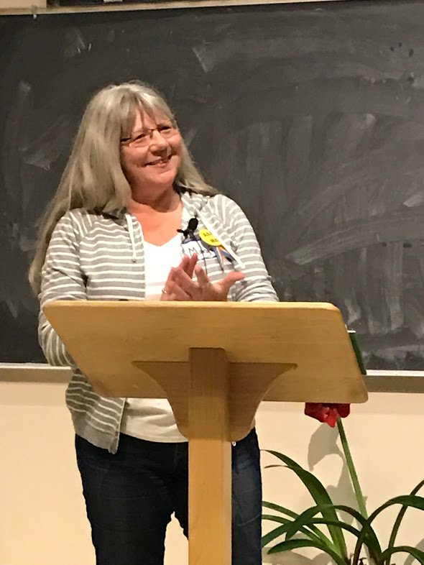

Margi Corbett, our ever-genial and very competent MC for the day!

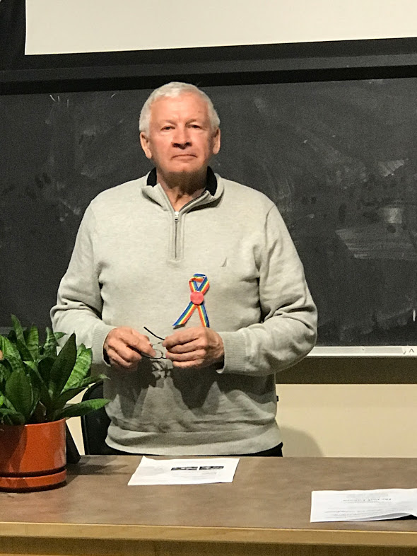

For many years, Doug Jaques made sure that all of our technological equipment behaved. This year, he drove all the way from Vancouver Island to provide us with that assurance one more time! Thank you, Doug!

Special greetings on our twentieth and last conference from Rick Mercer, Mark Tewksbury, Svend Robinson, and John Cornish.

Photos by Tom Rogers

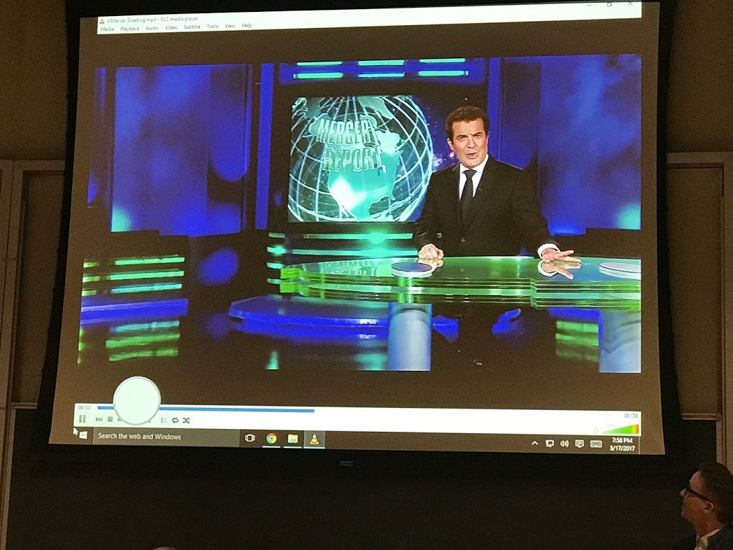

Special greetings to conference participants on video from Mr. Rick Mercer, CBC, The Rick Mercer Show.

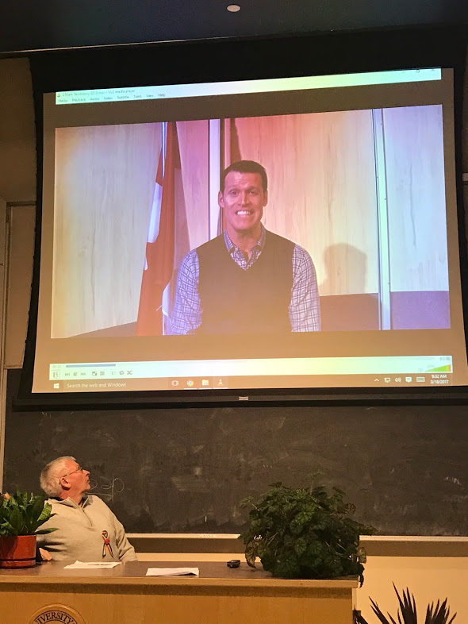

Greetings on our 20th from Mark Tewksbury

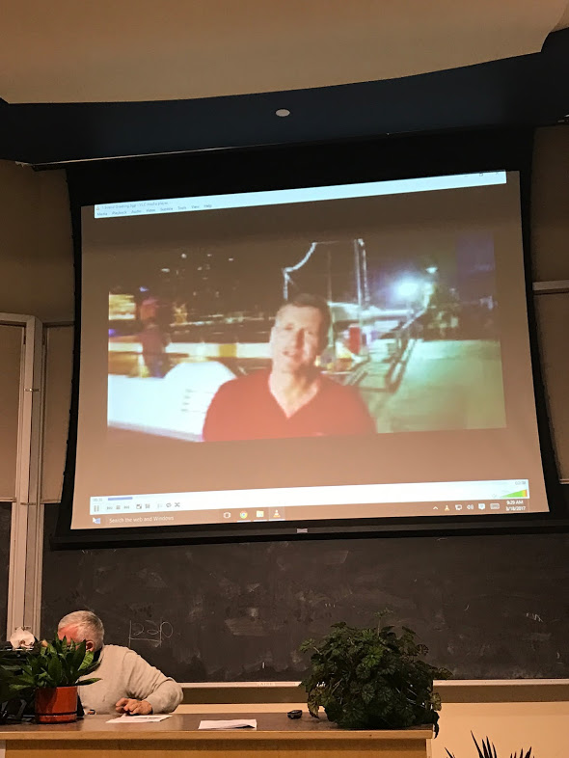

Greetings from Svend Robinson sent from the docks in Buenos Aires where he was just about to set sail for Antarctica to celebrate his 65th birthday!

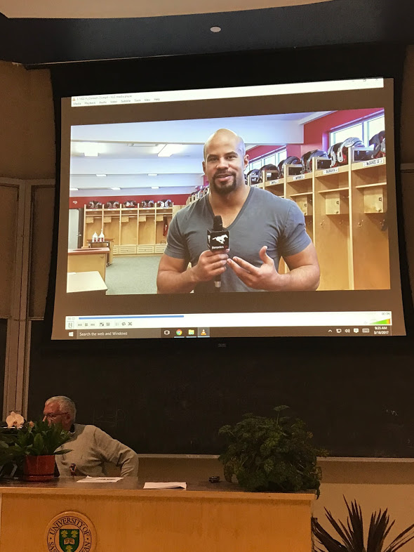

Jon Cornish, our special Friday-night presenter in 2013, sent greetings from the Stampeders dressing room!

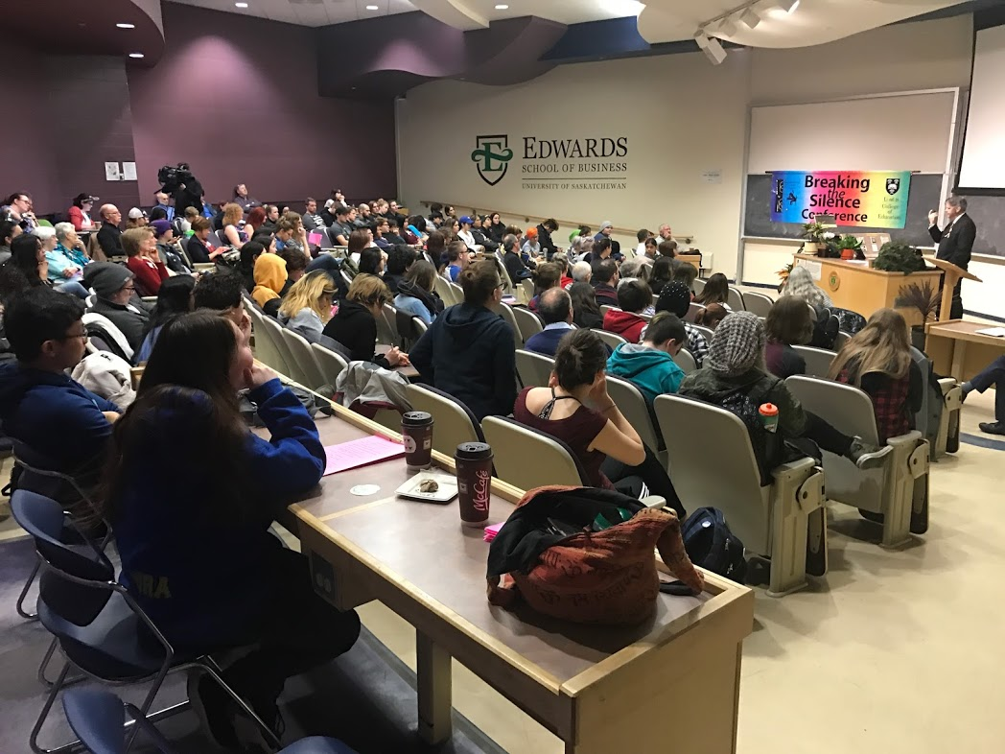

Photo of our final session by Tom Rogers

Media coverage
- “‘When you're gay in jail, it's a 24/7 job not to be outed’: Conference highlights LGBT issues in prison.” Front-page coverage in the Star-Phoenix, by Jonathan Charlton (March 18, 2017). http://thestarphoenix.com/news/local-news/when-youre-gay-in-jail-its-a-247-job-not-to-be-outed-conference-highlights-lgbt-issues-in-prison.
- Find CTV’s video at https://saskatoon.ctvnews.ca/u-of-s-celebrates-20th-breaking-the-silence-conference-1.3330843>.
- The Sheaf’s coverage: http://thesheaf.com/2017/03/16/breaking-one-final-silence-u-of-s-to-host-last-breaking-the-silence-conference/>.
. 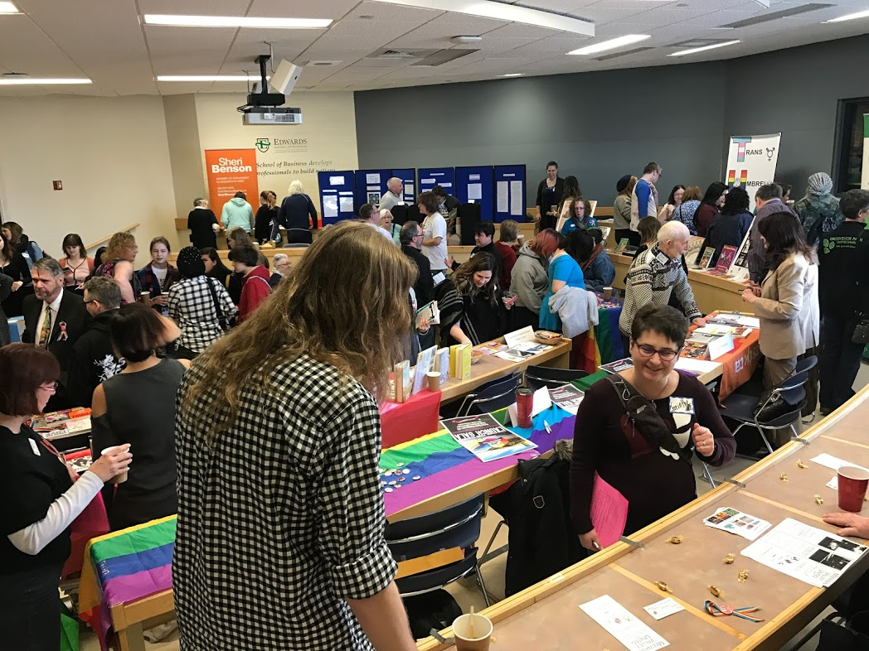

Our very active Display Room

Photo by Tom Rogers
In 1998, we proposed that the conference should have three major purposes. To what extent did we achieve our purposes?
- To create a forum for sharing information about gay and lesbian educational issues in Saskatchewan;
- To provide an opportunity in an academic setting for networking among those in the university and those in the wider community;
- To provide a stimulus for research into gay and lesbian educational issues in Saskatchewan.

Thanks to all who helped to organize our conferences and who participated in them for twenty years! You all contributed to the pursuit of our goals. Don
Appendix A—Greetings from the University

1998—Provost Michael Atkinson

1999— Acting Dean, Tom Wishart, College of Arts and Science

2000—President Peter MacKinnon

2001—Dean Robert Faulkner, College of Kinesiology

2002—Associate Dean Vivian Hajnal, College of Education

2003—Dr. John Thompson, President, St. Thomas More College

2004—Dean Cecilia Reynolds, College of Education

2005— Dean Cecilia Reynolds, College of Education

2006—Dr. Lea Pennock, University Secretary

2007—Dean Cecilia Reynolds, College of Education
2008—Dr. Sheila Carr-Stewart, Acting Associate Dean, College of Education

2009— Dr. Vivian Hajnal, Acting Dean, College of Education

2010—Peggy Schmeiser, Director, Government Relations, UofS

2011— Dean Cecilia Reynolds, College of Education

2012— Richard Florizone, Vice-President of Finance and Resources
2013— President Ilene Busch-Vishniac

2014— Dave Hannah, Associate V-P Student Affairs

2015—No Friday-night program

2016—____________________

2017—President Peter Stoicheff

Appendix B—Special Friday-night Presenters

1998—No Friday-night presenter

1999—Svend Robinson, M.P.

2000—Mark Tewksbury

2001—Pat Griffin

2002—Joe Arvay, Q.C.

2003—Bishop John Shelby Spong

2004—Pat Griffin

2005—Respect for Diversity Troupe (Saskatoon)

2006—Shawna Dempsey and Lorri Millan
2007—The Prairie Pride Chorus of Regina, Director David L. McIntyre

2008—The Committee to Defend Doug Wilson

2009—Kate Bornstein

2010—The Honourable Scott Brison, M.P.

2011—Marci McDonald
2012— Ivan Coyote

2013—Jon Cornish
2014—Elvira Kurt

2015—No Friday-night presenter

2016—Film: “Gen Silent” with Ashley Heaslip and Cheryl Loadman

2017—Play: The Pink Unicorn Cast: Kristi Friday—Director: Aaron Hursh

Appendix C—The Peter Corren Award, 2010-2017

Historical background: Peter and Murray Corren were quite extraordinary social activists living in Vancouver. In 2007, they worked their way into our hearts with their presentation on “Our Lives as Social Activists”. In my introduction, I would say something like this:
They challenged the adoption laws in BC—and won and then promptly adopted Brent. (1994-96)
Together, they introduced the first resolutions on sexual orientation issues at a Spring Conference of the BCTF— and won. (1996-97)
They quarterbacked and bank-rolled the Surrey Book Banning Case to the Supreme Court—and won. (1997-2002)
They were one of the eight couples in BC who challenged the marriage laws—and won. (2003-2005)
They sued the BC Ministry of Education over its failure to follow its own mandate by not providing materials on sexual minority issues—and won. (2006)
In fact, they have never lost! Don Cochrane

Peter died on December 30, 2009. The criteria for the award were formally approved by the Breaking the Silence Advisory Board on September 28, 2010:
- The Peter Corren Award for Outstanding Achievement may be given annually at the Breaking the Silence conference.
- The award should be granted to that person or those persons whose efforts have had a long-term impact. It could be granted posthumously.
- The award should be granted to those whose service/work was performed in Saskatchewan, or to those who have had a close relationship with communities in this province. The service/work may have been done outside of our province but would have affected us directly.
- The work undertaken by a nominee should be done in a field of education broadly defined.

Recipients

2010—Gens Hellquist

2011—Neil Richards

2012—Kay Williams

2013—Patty Rowley and Jim Komar

2014—Don Cochrane

2015—Pat Atkinson

2016—Alex Wilson

2017—Tony Bidulka and Herb McFaull, and Fran Forsberg

I am embarrassed to acknowledge that my Ethics in School Counseling (New York: Teachers College Press, 1995), co-written with John Schulte, was published without any mention of the crises faced by sexual minority students and teachers, and yet, by 1997, I was teaching a course entitled “Gay and Lesbian Issues in Education”. I underwent a significant transformation during those two years, but I am unable to give a satisfactory account—even to myself—of the major factors that contributed to that change.
Peter Millard (1932-2001) is the most notable and admirable exception. He joined the Department of English at the University of Saskatchewan in 1963. In 1973, he became an organizer and spokesperson in most of the province’s early battles to advance equal rights for gays and lesbians. He held leadership roles in the Gay Community Centre of Saskatoon, the Committee to Defend Doug Wilson, and the Coalition for Human Equality. On campus, he organized the Gay Academic Union in 1975 and became the mentor/protector of two generations of lesbian and gay students. In 1991, he taught the university’s first graduate, special topics gay studies course, an examination of social attitudes towards homosexuality in literature.
See Deidra Dionne, “Coming out can still be scary for Olympic athletes,” CBC Sports (September 27, 2017) <http://www.cbc.ca/sports/olympics/money-at-play/deirdre-dionne-coming-out-still-large-part-of-athlete-s-narrative-1.4309964>: “Changing a narrative doesn't happen with silence. It takes more conversation and more athletes to publicly engage in sharing their stories before being gay can truly become so commonplace that, frankly, it just isn't interesting or different.”
Life was simpler in those days! Very few had ever heard of inter-sex, transgender, gender queer, polyamorists, pansexual, and two-spirit people. We might now use queer as a general descriptor, but this would have been far too radical in the mid-90s to be included in a course proposal. During consideration of the course at a full faculty meeting, one member argued that the course should be more accurately called “Homosexuality and Education” rather than “Gay and Lesbian Issues in Education” (using the more colloquial phrase). “Homosexual” carried with it pathological associations from the list of mental disorders found in the American Psychological Association’s diagnostic manual. The term had been removed from the manual in 1972. The suggestion to change the title of the course was ignored.
He was the director of Saskatoon’s Gay and Lesbian Health Services (GLHS).
His reply is dated September 20, 1995. In our first year, we held one of our classes in GLHS’s downtown offices. GLHS has now morphed into OUTSaskatoon.
Memo Cheesman to Cochrane, November 2, 1995. He added that “the list of topics and readings seem[ed] carefully developed” and that “the consultation process [was] commendable.”
The original EFDT 486.3 has been renamed “Queering our Schools and Communities.” The course description has been updated and reflects a more activist approach: “Focuses on philosophical and pedagogical praxis surrounding contemporary lesbian, gay, bi-sexual, trans, two spirit, and queer (lgbttq) issues in education. Addresses inclusive/anti-homophobic curriculum, policy, resources and supporting students, teachers, counsellors, and administrators.”
Shelley Lynne Balanko’s Anti-gay Violence at the University of Saskatchewan: Occurrences, Mental and Physical Health Consequences, and Perceived Effectiveness of Support Systems (Department of Psychology, June 24, 1997) was among the first M.A. theses in our university’s history to be devoted exclusively to LGBT issues.
Once again, we relied on Gens Hellquist. We had no contacts with any LGBT youth and there were no GSAs at that time in any of our schools. Through his youth group at GLHS, my student, Lisa Fedorowich, was able to arrange for interviews. Her paper was entitled “Saskatoon schools: Are they safe for gay and lesbian youth?” This may have been the first research of its kind with young people in the province.
The first advisory board consisted of Myrna Rolfes and Kay Williams (PFLAG), Lisa Fedorowich (Graduate Education Student), Gens Hellquist (GLHS), Susan Vincent (U of S Education Equity Co-ordinator), Sharon Fyke (School Counsellor, Aden Bowman Collegiate), Neil Richards (U of S Library), Rae Vogel (Teacher), Lesley Biggs (Women and Gender Studies), Scott Blythe (USSU Academic V-P), Dayvid Campbell (Doug Wilson Award Liaison and Undergraduate Student), George Georget (STF), Jackie Kircough, Megan Norman, and Shannon Nutall (LGB Centre), Angela Ward (College of Education), Andrew Sneddon (ESS President) and myself (College of Education). Kay remained a board member for twenty consecutive years!
Dan Ish (College of Law), chair of the university’s Speakers Committee, had invited Delwin Vriend to address law students and we were able to take advantage of his being on campus. We learned about this opportunity from Daryl Mitchell, GLUS Secretary (December 11, 1997). Delwin discussed his Supreme Court case [Vriend v. Alberta] concerning the inclusion of sexual orientation as a protected human right in Canada. For more recent news about Delwin, see “Reluctant gay rights hero seeks serenity abroad: Delwin Vriend looks out the window of his apartment in the heart of old Paris” by Sheila Pratt, The Edmonton Journal, March 30, 2008 <http://www.canada.com/story.html?id=a9d33a8e-a17c-4b6f-bb88-1a55049c8f78>. See also <http://www.iheartedmonton.ca/2015/06/the-trial-of-delwin-vriend.html>.
Vriend had been a laboratory coordinator and chemistry lab instructor at King's University College (a Christian college) and had been given a permanent, full-time position in 1988. Throughout his term of employment, he received positive evaluations, salary increases, and promotions for his work performance. He was fired in 1991 because he was gay. In November 1997, the case reached the Supreme Court and its decision was rendered on April 2, 1998. In a landmark case, the court unanimously ruled that the exclusion of homosexuals from Alberta's Individual Rights Protection Act was a violation of the Charter of Rights and Freedoms. Interesting interviews (2013) with Delwin can be found at <https://www.youtube.com/watch?v=cT6OoVLmGTY>, and <https://www.youtube.com/watch?v=Pv6RZpkoiCQ>.
14 For a moving account of the first conference, see Bernadette Richards, “Breaking the Silence” in the STF Bulletin, 64 (10), April 1, 1998, p. 1, 3: “This was the first public forum in Saskatchewan for educators to begin talking about the reality of gays and lesbians in schools.” See also the Moose Jaw Times Herald, March 23, 1998, p. 2.
Pat Atkinson was the recipient of Breaking the Silence’s Peter Corren Award in 2015.
REAL Women of Saskatchewan is the provincial branch of REAL Women of Canada (the word REAL is an acronym for Realistic, Equal, Active, for Life). The parent organization was formed and incorporated in 1983 and is a non-profit, non-partisan, non-denominational organization. REAL Women speaks for women who support the values of traditional family and marriage.
Maurice Vellacott represented this constituency as a member of the Reform, Alliance, and Conservative parties from 1997 to 2015. Vellacott was a social and economic conservative.
Promise Keepers was founded in 1990 in the United States and spread to Canada in 1995 as the first international expansion of the ministry through its Promise Keepers International. It is often criticized for advancing a very traditional view of the family and the roles of men and women in it.
The conference generated some negative reaction in the press. Dean Ken Jacknicke received a protest letter from a Hal Adam in which he wrote, “If this is true (that Delwin Vriend would speak), why are you allowing some to prompt [sic “promote”?] their personal perversions to the children of Saskatchewan? Rather than prompting (sic) this, you should be warning students of the great danger of getting aids (sic) (and an early death) if they choose to engage in homosexual’s (sic) perverted practices.” Ben Heppner, a school teacher for twenty-two years (he took his B.Ed in the College of Education in the University of Saskatchewan), a politician for eleven years, a Progressive Conservative (Rosthern) MLA and a Sask Party MLA (Martensville) (1996-2005), wrote a column (March 30, 1998) in which he pointed out that tuition was rising, buildings were collapsing…but the “U of S does have money to sponsor a gay and lesbians conference on issues from elementary to university.” He concluded sarcastically, “I guess we all have to make choices.” And Reg Hoegl (Lloydminster) wrote to the Star-Phoenix (March 30, 1998) to say that he had attended the conference and was critical. Among other things, he disagreed that colleges and schools should offer courses to combat “homophobia” (a discriminatory and emotionally charged word he claimed had been invented by the “gay lobby”). Not all the reaction was negative. Susan Vincent (Equity Co-ordinator, University of Saskatchewan) responded with a letter to the editor in the Star-Phoenix (April 1, 1998) under the heading “Gay conference broke the silence on subject”. Colleen Gerwing wrote a letter to the paper to compliment Pat Atkinson “for encouraging schools to become more gay-friendly and Neil Richards for being honoured with the Doug Wilson Award.”
Svend Robinson was a Member of Parliament in the Canadian House of Commons representing his B.C. Burnaby-Douglas constituency from 1979 to 2004. He is recognized as the first MP in Canadian history to come out as gay while in office.
Svend remained a “friend of the conference.” See his greetings to Scott Brison, our special presenter in 2010, and his final tribute to our conference in 2017.
See Jason Warick, “Schools must improve welcome for homosexuals, teacher says,” Star-Phoenix, March 15, 1999.
See “A sports hero declares he’s gay,” Globe and Mail, December 15, 1998, A1, p. 10. Mark’s account of his coming out can be found in his own Inside Out: Straight Talk from a Gay Jock (Mississauga, ON. Wiley and Sons Canada, 2006) to his family (p. 73-76), to the public (p. 111-112), and in the media (162-166). See also his Visions of Excellence: The Art of Achieving Your Dreams (Toronto: Viking, 1993). The vividness of Mark’s prose matches the sparkle of his personality. Both are infectious.
See The Sheaf, 91(29), (March 23) 2000, A1, A8; Saskatchewan Bulletin, April 5, 2000, p. 5; and the Star-Phoenix, March 18, 2000.
See Mark’s welcome to Jon Cornish in 2013.
The Sheaf, op. cit.
Barb Byers’ address was entitled “Combating homophobia in the workplace”. She was a recipient of the Order of Canada in 2016.
The Saskatchewan Teachers’ Association (STF), the Saskatchewan School Trustees Association (SSTA), and the League of Educational Administrators, Directors, and Supervisors (LEADS).
For an account of the panel discussion, see Theresa Kirkpatrick, “Society must have respect, value for every person,” Prairie Messenger, March 29, 2000, p. 14-15.
At the time, Jim was a school superintendent in the Prairie Valley School Division. He became an outspoken LGBT advocate among his staff and teachers. Later, he served as president and chief executive officer for the Saskatchewan Roughriders of the Canadian Football League (CFL) (2005 until 2014) where he carried his advocacy into the dressing room.
Saskatchewan Bulletin, April 4, 2001, p. 3. See also two full-length articles in the Weekend Extra section of the Star-Phoenix by Kim McNairn: “The last closet: Gay teachers don daily disguise” and “Political sentiment effective weapon,” March 17, 2001.
Joe Arvay took over seventy-five cases to the Supreme Court of Canada, many of them focused on human rights. He was made an Officer of the Order of Canada in 2017.
Robert Enright’s obituary for Peter Millard appeared in Globe and Mail, Focus, F8 (January 5, 2002) at < https://www.theglobeandmail.com/incoming/scholar-shaped-prairie-citys-cultural-life/article4141383/>. Peter died on December 8, 2001.
Perceptions, 17(8) (December 8, 1999) p. 19; Jason Warick, “Public board tackles gay issues,” Star-Phoenix (September 4, 2001), p. A1, A3; “The Report of the Adhoc Committee on Lesbian, Gay, Bisexual, and Transgendered Issues” (June, 2000).
See “Teachers hear of problems faced by gay, lesbian students—Meeting tackles issues of homosexuality in schools,” Star-Phoenix, March 18, 2002, A5.
Bishop Spong had discussed gay and lesbian issues in many forums. See, for example, “A catechesis on homosexuality” written with Rt. Rev. Peter John at the suggestion of the Archbishop of Canterbury <http://www.jmm.org.au/articles/14919.htm>. See Gavin Logan, “Breaking the silence with Bishop John Shelby Spong,” The Sheaf, March 27, 2003, 94(30), A4; Terry Craig, “Spong addresses Breaking the Silence conference,” Prairie Messenger, April 2, p. 3; Janice Sanford Beck, “The Christ who breaks the boundaries of prejudice,” The Saskatchewan Anglican, May, 2003, p. 2-3; “Spong said church has to break down its prejudices,” Saskatchewan Bulletin, 69(9), (April 16) 2003, p. 2.
Bishop John Shelby Spong, A New Christianity for a New World, May 7, 2003.
2004 was a significant year! On November 5, 2004, same-sex marriage was approved in Saskatchewan. The plaintiffs consisted of five same-sex couples: Erin Scriven and Lisa Stumborg, Lenore Swystun and Kelley Moore, James Hein-Blackmore and William Hein-Blackmore, Nicole White and Julie Richards, and Martin Bonneville and Ted Atkins. Madam Justice Donna Wilson of the Family Law Division of the Court of Queen's Bench sided with courts in five other provinces and one Canadian territory. She ruled that existing provincial laws discriminated against same-sex couples. She wrote: “The common-law definition of marriage for civil purposes is declared to be 'the lawful union of two persons to the exclusion of all others'.” Scriven and Stumborg were married the following week.
https://ussu.ca/wp-content/uploads/2014/04/USSU2003-04AR.pdf
“While Rowley said she has had no negative feedback from students or parents about the club, teacher Margi Corbett said students at Hague High School have aggressively opposed her efforts to address gay and lesbian issues. ‘Gay-straight alliances are years away, light years away in my community, and that is probably normal for small towns,’ said Corbett, an English teacher. ‘In my community, it is very, very dangerous for any student to speak out against homophobia because homophobia is part of the culture’.” Dan Kinvig, “Gay-straight group touted,” Star-Phoenix, March 22, 2004, A4. Yes, we have all travelled light years since 2004!
See Stephanie Classen’s “Gender outlaw in town,” Star-Phoenix, March 11, 2009, C1.
Peter died on December 30, 2009. See <https://www.dailyxtra.com/peter-corren-remembered-for-his-unrelenting-activism-11253> and <https://www.straight.com/news/vancouver-gay-rights-pioneer-peter-corren-dies>. Peter and his husband Murry Corren had made a special presentation entitled “Our Lives as Social Activists” to our conference in 2007. The award was created shortly after we learned of Peter’s death.
Author of The Armageddon Factor: The rise of Christian nationalism in Canada (Toronto: Random House Canada, 2010). She has also published Yankee doodle dandy: Brian Mulroney and the American agenda (Don Mills, ON: Stoddart, 1995) and Out of character: A memoir (with Maureen Forrester) (Toronto: McClelland and Stewart, 1986).
Neil’s activities in support of LGBT initiatives are legion and legendary. In 1975, he and others joined to form the Committee to Defend Doug Wilson. In 1976, Neil helped organize the convention of the National Gay Rights Coalition in Saskatoon, which was among the first significant gay rights gatherings in Canada. He worked on many of the earliest AIDS awareness initiatives in Saskatchewan. In 2004, he was instrumental in developing an online resource “Saskatchewan Resources for Sexual Diversity” at the University of Saskatchewan and in 2008, he spearheaded the initiative to have the Surrey Book Banning Case papers accepted by the Archives at the University of Saskatchewan. Neil received the 1998 Doug Wilson Award and the first ever President’s Service Award in 1995 —both at the University of Saskatchewan; in 2000. He was inducted into the Canadian Lesbian and Gay Archives for its National Portrait Collection. In 2005, he was the recipient of the Saskatchewan Centennial Medal and, posthumously, in 2018, the Saskatchewan Order of Merit. Neil died on January 12, 2018.
These two clerics had a joint ministry at Holy Trinity Anglican Church in Saskatoon. When Emily revealed that she was a lesbian and had married a woman over the Christmas holidays, she faced hostility from many members of her congregation. After several meetings with them, she resigned. Beck then resigned in solidarity.
For converage, see Planet S, March 20-April 2013, Volume 10, Issue 15, p. 8-9: http://old.planetsmag.com/story.php?id=1162.
For Global TV coverage, see https://globalnews.ca/news/412805/conference-tackling-homophobia-in-the-locker-room/.
For a newspaper account of Cheryl’s work, see Sean Trembath’s February article in the Star Phoenix at <http://thestarphoenix.com/news/local-news/care-homes-unfriendly-for-lgbt-seniors>.
See Sheri Benson’s tribute to Tony, Herb, and Fran in the House of Commons, April 10, 2017 at https://vimeo.com/212759776.

